**Software Development Project on**

**MEDICS**

In partial fulfillment of

Bachelors of Computer Applications (BCA)



Gujarat university (2022-2023)

(Third year of the bachelor of computer applications) **Project created by:**

Group number: - 02

Bhavik Manwani [55]

Dhrumil Karia [40]

Dhruv Pandya [68]

**Lokmanya College of Computer Applications (LCCA)**

**Shivranjani cross road, 132 feet Ring Road,**

**Satellite, Ahmedabad-380008**

**Contact:- (079)-26920259**



**Acknowledgment**

We have taken efforts in this project however; it would not have been possible without the kind of support and help of many individuals. We would like to extend our sincere thanks to all of them.

We are highly indebted to **Prof. Sejal Vaghela** for their guidance and constant supervision as well as for providing necessary information regarding the project. We take this opportunity to thank all of our friends who provided extremely useful reviews and for their all-time support and help in every aspect of the course of the project preparation. We are grateful to our college, **Lokmanya College of Computer Applications**, Ahmedabad for providing us with all the required resources and a good working environment.

Finally, we would like to thank everyone who directly or indirectly helped us in this project, With thanks to all.

TABLE OF CONTENTS

**INTRODUCTION**

74

Future Enhancement

75

Conclusion

76

Bibliography

61

Report Layout

26

Screen Layout

06

Project Profile

16

Introduction

Organization Profile

15

The internet has taken over the world in all aspects. Not sparing any field, it is not surprising that even pharmacies have gone online. An online pharmacy refers to a business organization involved in selling pharmaceutical preparations like non-prescription and prescription-only drugs, by ordering them online and delivering them through email. About **32,500 online pharmacists working worldwide** aim to promote public health by the legal framework of the country and thus fulfill the successful vision of Digital India.

An **E-Pharmacy** is a pharmacy that operates over the internet by selling drugs, and medicines & sending them to customers. The Internet makes all things easy & convenient. Patients can now buy use prescriptions from registered medical practitioners order medicines via the use of the internet & receive them at their doorsteps. They are a massive hit & more and more people are opting to use them rather than a stroll down to local pharmacies.

Definition:

* The application of the internet to access drugs and diagnostics which begin early in the advent of the info age has matured into portals or virtual drug stores popularly known as **“Internet Pharmacy” or “Online Pharmacy” or “Web Pharmacy” or “Cyber Pharmacy”.**
* **E-Pharmacies** are **online platforms** where consumers can purchase medicines without having to visit **brick-and-mortar pharmacies.** This makes the process more convenient for consumers and has resulted in a rising demand for the model across the world.
* In addition, the increasing utilization of e-Prescription in hospitals globally has also led to the growth of this industry.

**Types Of E-Pharmacy:**

**Inventory based model**

This model implies an action where the stock of merchandise and ventures is possessed by the eCommerce organization and the items are offered to the client legitimately. Likewise, in e-Pharmacies, the e-Pharmacy possesses the stock of medications/drugs that are put away in stockrooms/warehouses focused across geographic areas.

**Marketplace model**

Marketplace-primarily based totally version of eCommerce way that the era groups act as a facilitator among a purchaser and a seller. In this version, e-Pharmacy performs the function of an aggregator.

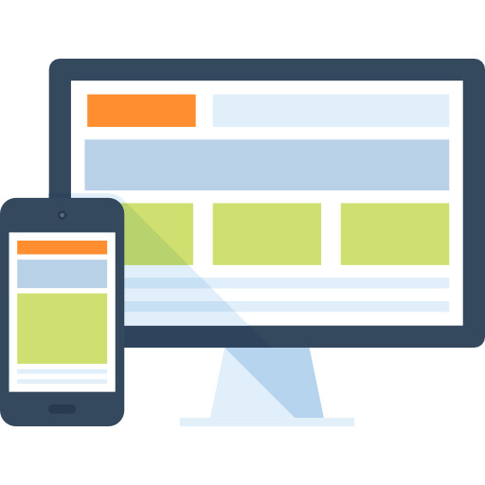**Market Place Model:**

**Inventory Based Model:**

**Customer**

**Website**

**Licensed Pharmacy**

**Customer**

Inventory-based e-commerce means an activity where the inventory of goods and services is owned by the e-Commerce entity and is sold to customers directly.

Market place model of e-commerce means providing an information technology platform by an e-commerce entity on a digital and electronic network to act as a facilitator between buyer and seller.

**Components of e-Pharmacy:**

**Technology:**

* Web-based or mobile-based application for consumer transmits their prescriptions and place request for medicines.
* Order that is received verified and checked by a registered pharmacist.
* The registered pharmacists forward the verified prescription to the pharmacy store from where the medicines are dispensed by a licensed pharmacy.
* The web or mobile-based platforms are governed under the IT Act 2000.

**Pharmacy retail store:**

* The registered pharmacist at the store verifies the prescription before dispensing it.
* The medicines are dispensed from the licensed premises to the patient.
* An Invoice with batch number of medicines dispensed, expiry date, name, and address of the pharmacy with the signature of the registered pharmacist is issued online.

**Company Profile:**



|  |  |
| --- | --- |
| Janovis Infotech | |
| Company Name: | Janovis Infotech |
| Address: | 910, Shivalik Shilp, Iskon Cross Road, Ahmedabad-380008 |
| Email: | info@janovisinfotech.co.in |
| Contact no.: | +91 90169 10353 |
| Website: | www.janovisinfotech.co.in |

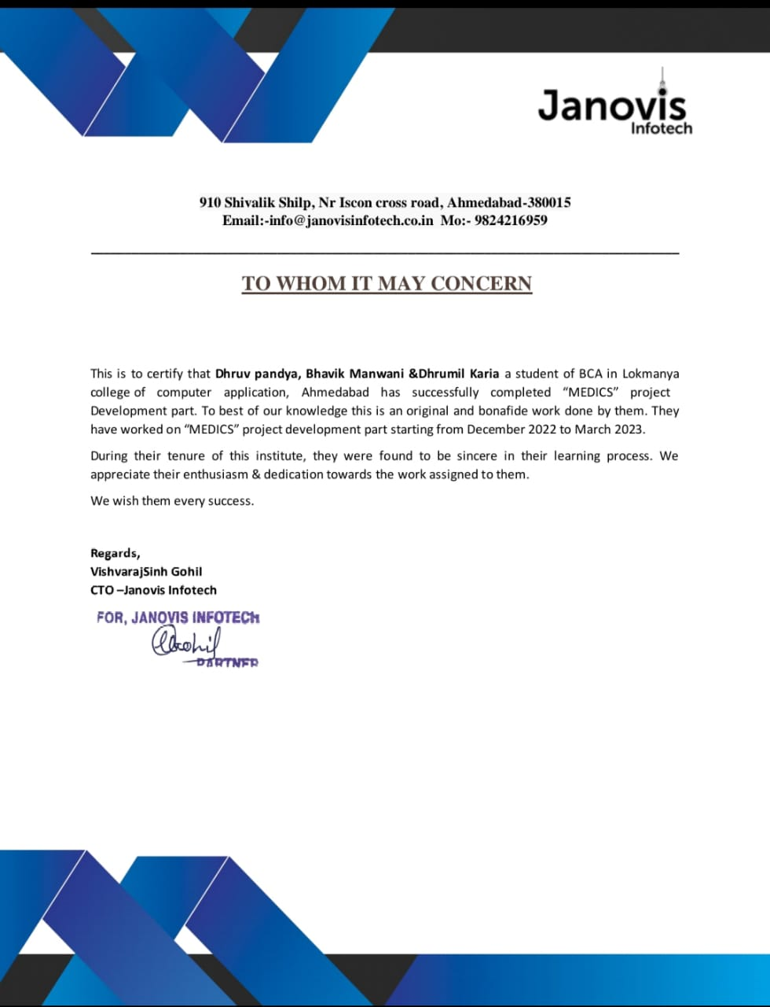

**Project Profile:**

|  |  |
| --- | --- |
| **Project title** | MEDICS |
| **Group no.** | 02 |
| **Group members** | Bhavik Manwani [55]  Dhrumil Karia [40]  Dhruv Pandya [68] |
| **Internal guide** | Prof. Sejal Vaghela |
| **External guide** | Vishvarajsinh Gohil |
| **Front-end** | Python 3.10, VS-Code 1.7.1 |
| **Back-end** | MySQL 8.0.30 |

**Existing System:**

* Time Consuming: Sometimes drugs are not available at nearby pharmacy stores they may prove to be time-consuming for the elderly and busy scheduled people to see proper drugs at right time to prevent the risk to patient’s health.
* Price: The price of drugs is more than online pharmacy medicines due to middle man’s profit. The patient due to its poverty may find difficulty in buying costly and branded drugs which may prolong its long-term disease.
* Inconvenience: Chronic elderly patients who are not able to go to pharmacy stores may cause difficulty in finding stores situated at long distances or in unrelated places.
* Fixed Time availability: Remains open for fixed time and fixed days of the week.
* Inconvenient: Chronic elderly patients who are not able to go to pharmacy store may cause difficulty in finding the stores situated at long distances or unrelated places.
* Slower Distribution: The Supply chain is slower.
* Less Reliable: compare to e-pharmacy

Less Reliable.

* Lesser Range of choice: Has Limited range of choices in Medicines and other supplies.
* Not Private at all: Consumer’s Information is not confidential

**Proposed System:**

• It is very easy to order prescription drugs through E-Pharmacy. Especially for people who live far away from a traditional pharmacy, the elderly, disabled people, and those who work very intensively, this system is both a very easy and a very fast method of obtaining medicine. Additionally, the shipping cost is much cheaper than traveling to a traditional pharmacy.  
• One of the most important advantages of the E-Pharmacy application is time-saving. You can order your medication within minutes and get your prescription medicines very quickly. All you have to do is to place an order by entering the prescription through the mobile application or website. You do not have to go to the pharmacy and you will not be faced with waiting in line at the pharmacy.

E-Pharmacy, which offers a much wider range of options than a traditional pharmacy, provides a great advantage to patients. It is not possible to find every drug in a physical pharmacy in a particular area, but there are many more drug options available in general drug stores.

1. **Convenient:**  Online pharmacy serves a convenient way of buying medicine for old age, physically challenged and working professionals, due to the difficulty for them to go local medical shop.
2. **Discounted rates:** wider reach, reduced operational cost, reduced labor cost, and ability to provide a pocket-friendly deal on the medicines to your customers.
3. **Range of choices:** E- pharmacy has more extensive stocks of medicine than conventional pharmacies; it offers a huge variety of options. Therefore, it is guaranteed that you can get any medicine that you are searching for.
4. **Anytime anywhere:** You can place your order anytime from anywhere as there is no issue with the pharmacy closing down. 24*7 online customer supports are there to solve your queries regarding medicines.
5. **Information is private and confidential**:The information that you have provided during the purchase of medicine is usually private and confidential in an online pharmacy. This approach is beneficial for those people who feel embarrassed or shameful to speak face to face about conditions like erectile dysfunction, acne, STDs, and hair loss
6. **Systematic:**  Online stores have the process of drug approval, before dispatching the medicines to the consumer they require a prescription which is reviewed by a qualified pharmacist
7. **Easy secured payments:** Online pharmacy provides the facility of cashless payments either by credit or debit card, Paytm or you can also pay by cash on delivery.
8. **Facilitate useful information:** Online pharmacy websites provide beneficial information regarding drug interaction and side effects of medicine in the form of product facts, blogs, or articles.

|  |  |
| --- | --- |
| **Tools And Technology** | |
| **Hardware Requirements** | |
| **Operating System** | Windows 7 or above |
| **RAM** | Minimum 1 GB; Recommended 4 GB or above. |
| **HDD** | Minimum 32 GB; Recommended 64 GB or more. |
| **Software requirement** | |
| **Front-end** | Python 3.10 |
| **Back-end** | MySQL 8.0.30 |
| **Other tools** | VS Code 1.7.1 |
| **Server** | Apache HTTP server |
| **framework** | Django 4.0 |

**Feasibility Study:**

Project management is the process of planning, organizing, and managing resources to bring about the successful completion of specific project goals and objectives. A feasibility study is a preliminary exploration of a proposed project or undertaking to determine its merits and viability. A feasibility study aims to provide an independent assessment that examines all aspects of a proposed project, including technical, economic, financial, legal, and environmental considerations. This information then helps decision-makers determine whether or not to proceed with the project.

The feasibility study results can also be used to create a realistic project plan and budget. Without a feasibility study, it cannot be easy to know whether or not a proposed project is worth pursuing.

**Types of Feasibility Study**

A feasibility analysis evaluates the project’s potential for success; therefore, perceived objectivity is an essential factor in the credibility of the study for potential investors and lending institutions. There are five types of feasibility study—separate areas that a feasibility study examines, described below.

**1. Technical Feasibility**

This assessment focuses on the technical resources available to the organization. It helps organizations determine whether the technical resources meet capacity and whether the technical team is capable of converting the ideas into working systems. Technical feasibility also involves the evaluation of the hardware, software, and other technical requirements of the proposed system. As an exaggerated example, an organization wouldn’t want to try to put Star Trek’s transporters in their building currently, this project is not technically feasible.

**2. Economic Feasibility**

This assessment typically involves a cost/ benefits analysis of the project, helping organizations determine the viability, cost, and benefits associated with a project before financial resources are allocated. It also serves as an independent [project assessment](https://www.simplilearn.com/risk-assessment-project-management-article) and enhances project credibility—helping decision-makers determine the positive economic benefits to the organization that the proposed project will provide.

**3. Operational Feasibility**

This assessment involves undertaking a study to analyze and determine whether—and how well—the organization’s needs can be met by completing the project. Operational feasibility studies also examine how a [project plan](https://www.simplilearn.com/project-management-plans-in-project-environment-rar79-article) satisfies the requirements identified in the requirements analysis phase of system development.

**4. Scheduling Feasibility**

This assessment is the most important for [project success](https://www.simplilearn.com/how-to-make-a-project-successful-article); after all, a project will fail if not completed on time. In scheduling feasibility, an organization estimates how much time the project will take to complete.

**Screen Layout:**

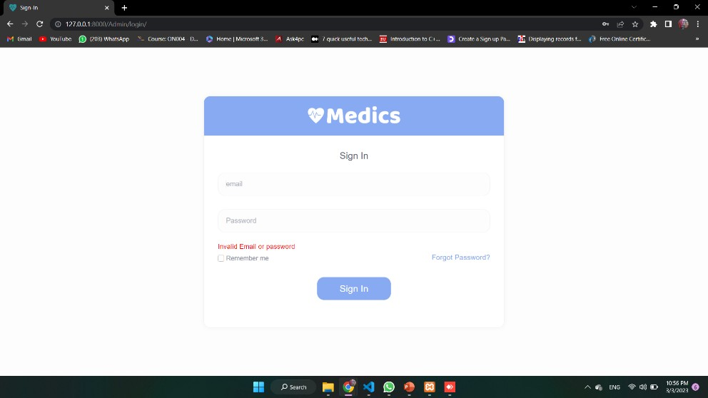**Admin Login Page**

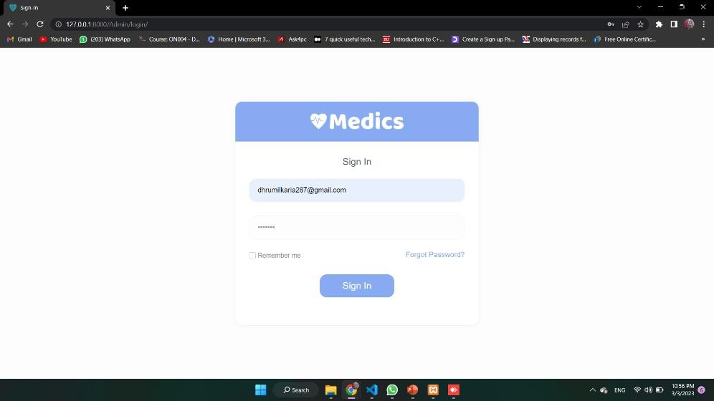**Login successfully**

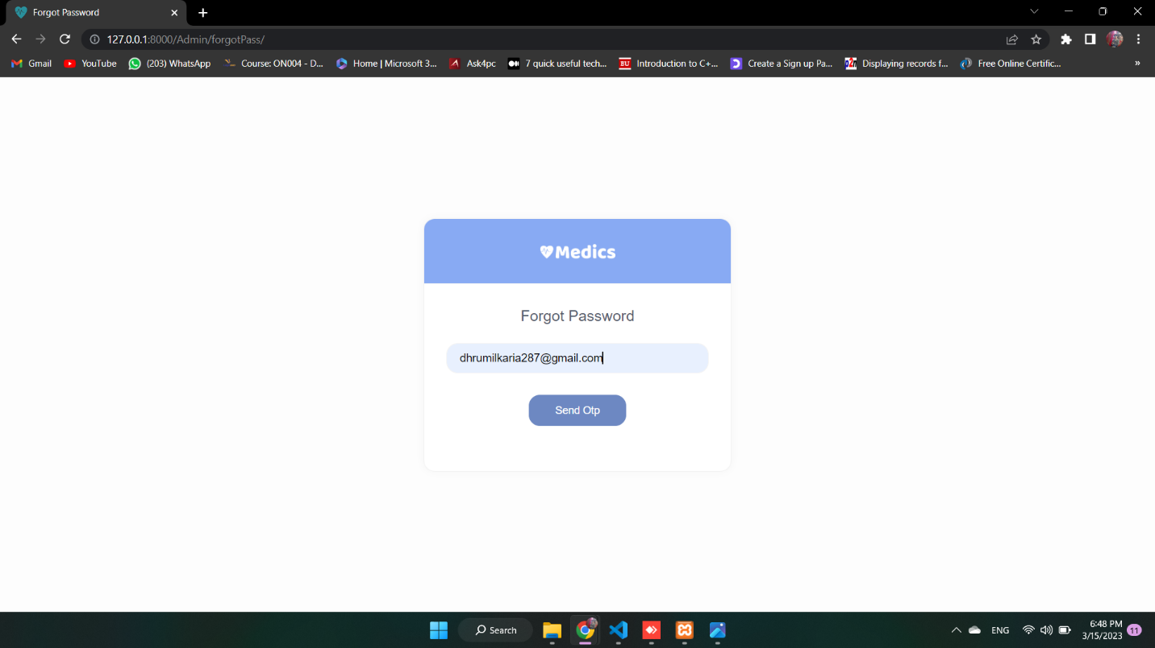**Admin Forgot Password Page**

**Admin Send OTP & New Password Page** 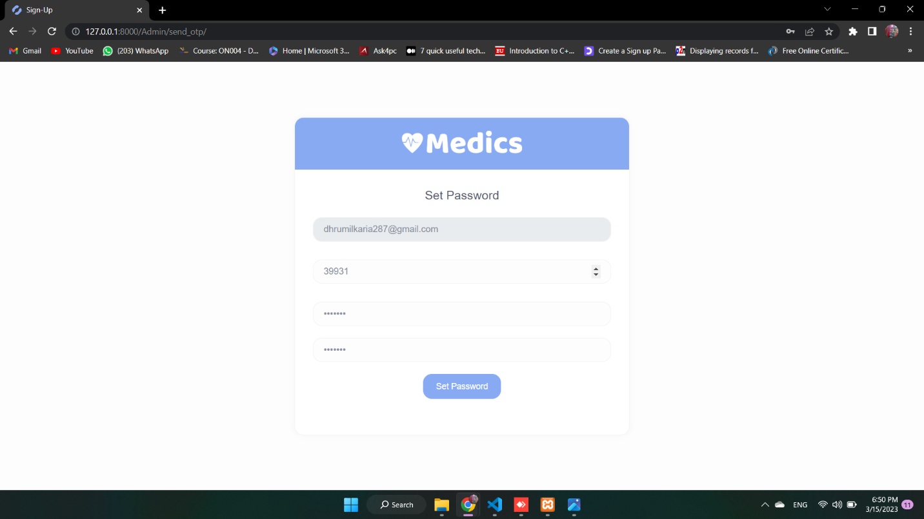

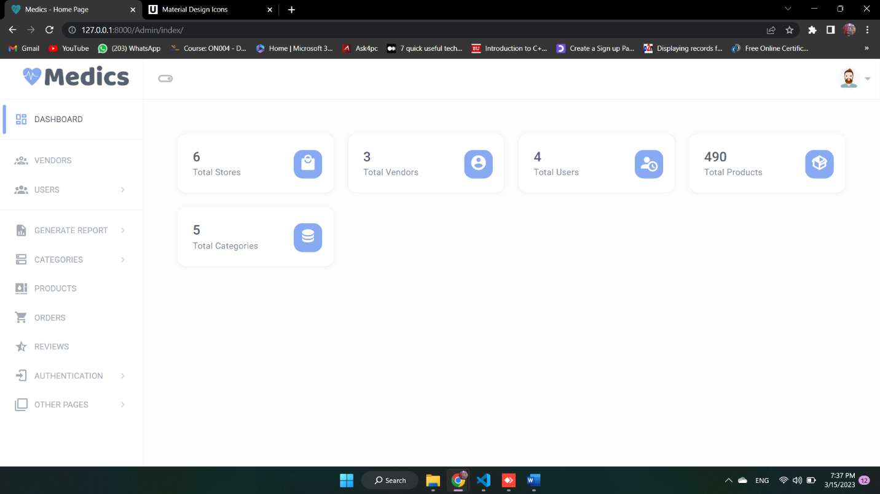**Admin Dashboard**

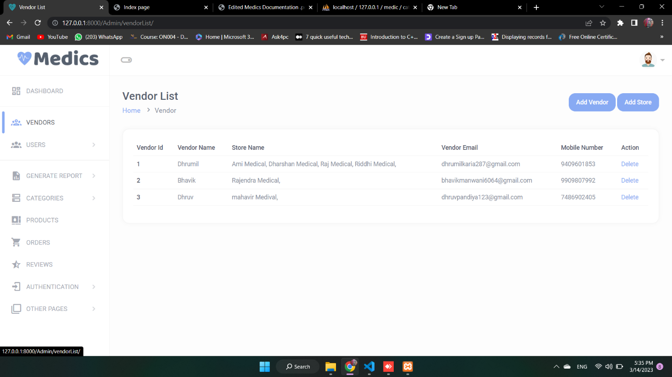**Vendor List**

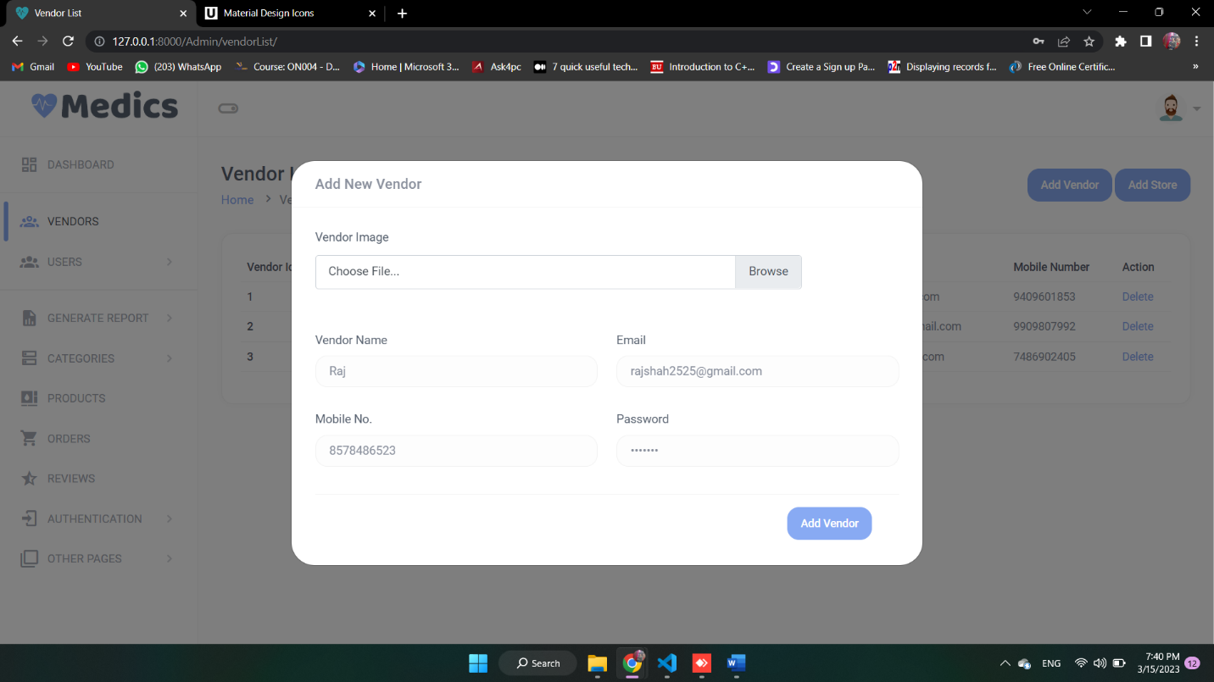**Admin Add Vendor**

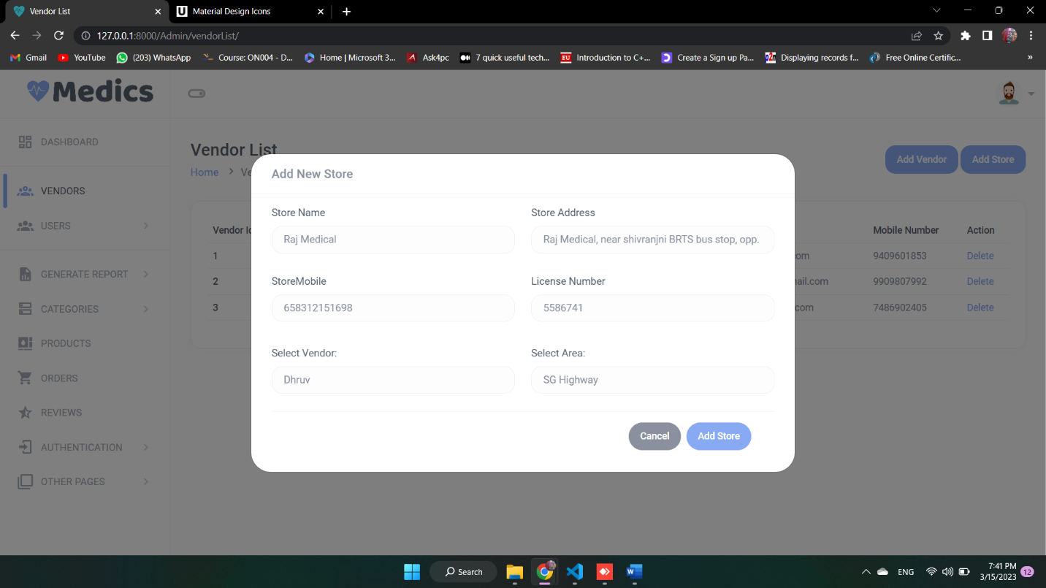**Admin Add Store**

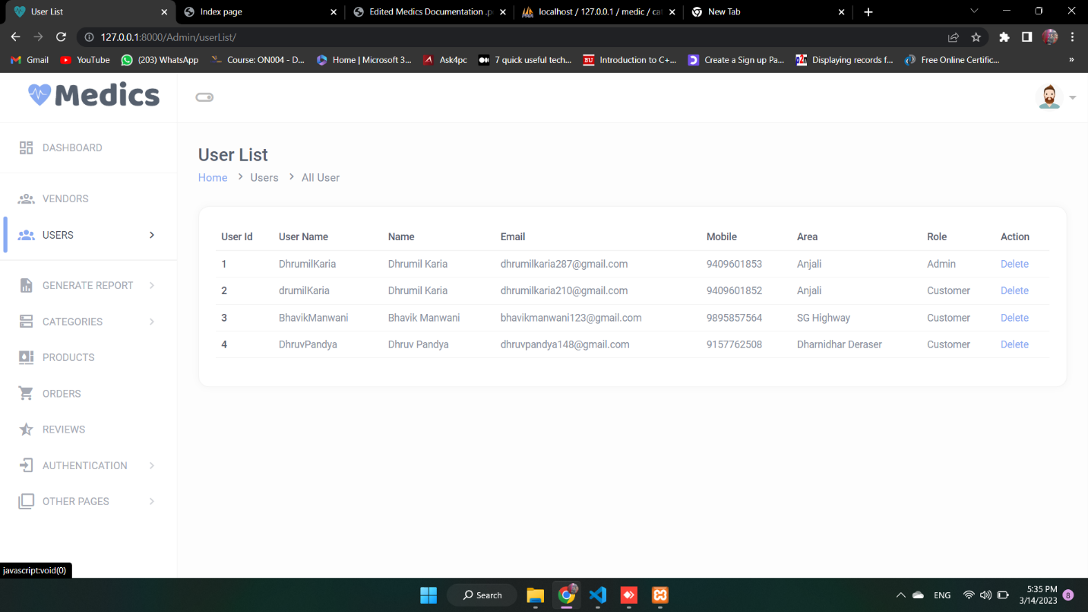**User List**

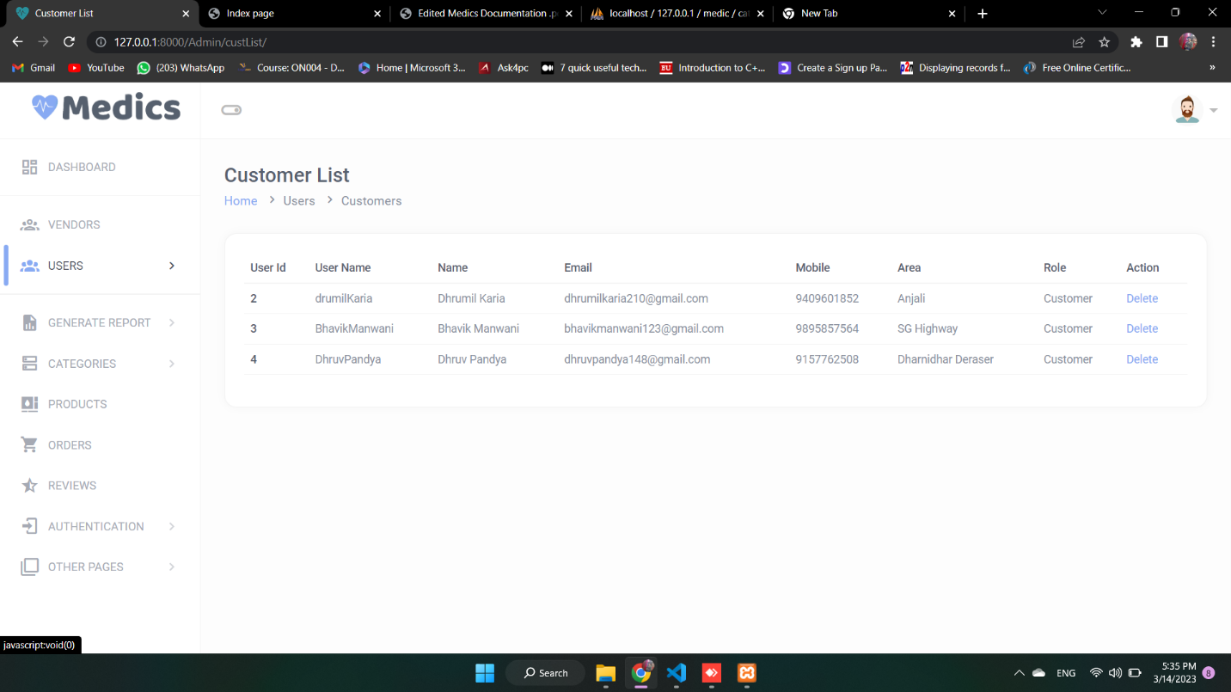**Customer List**

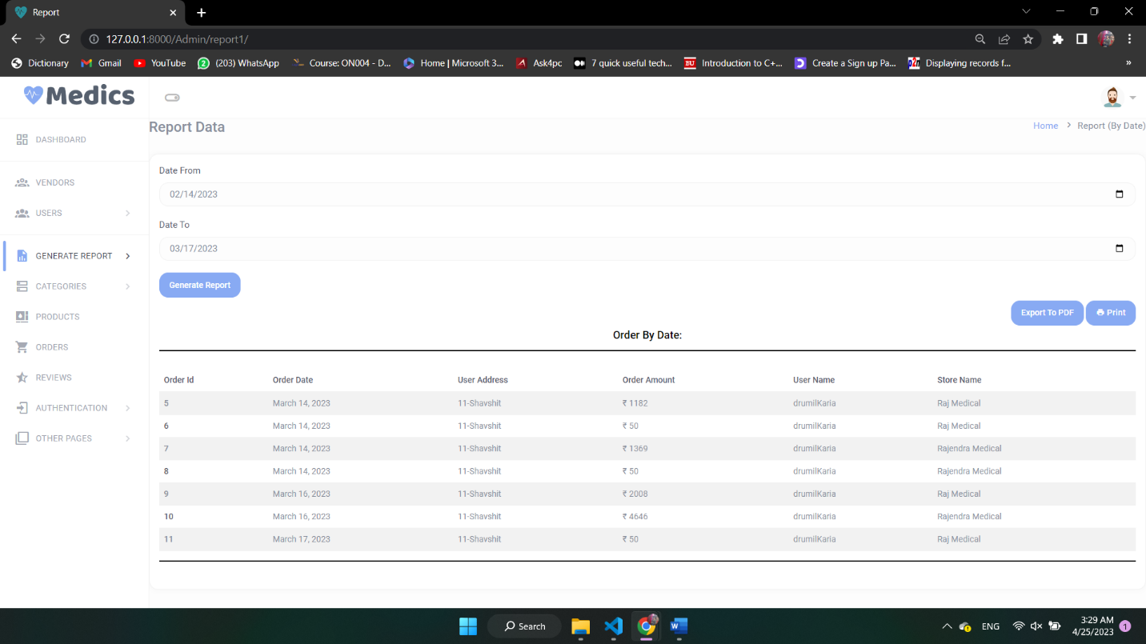**Report By Date**

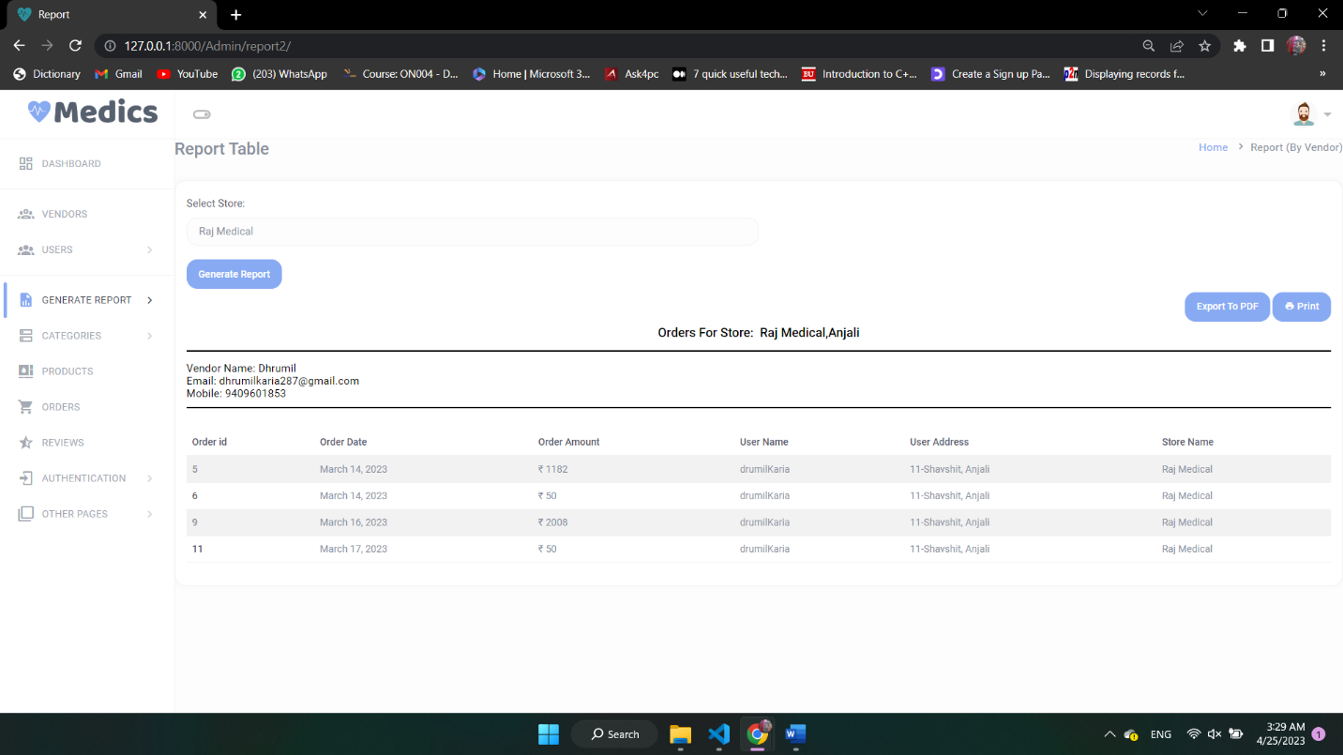**Report By Vendor**

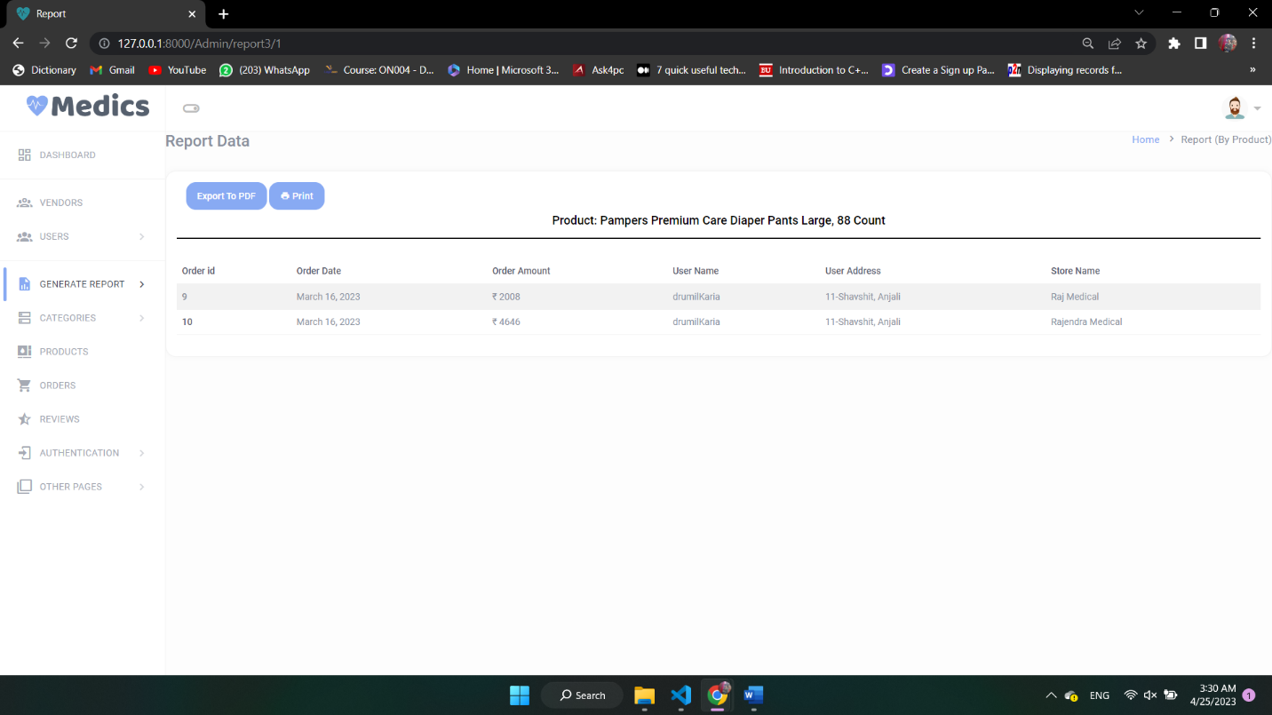**Report By Product**

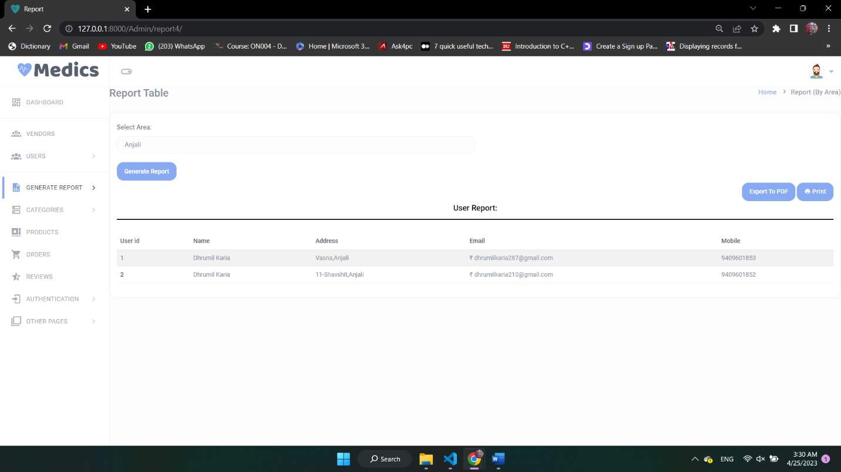**Report By Are**

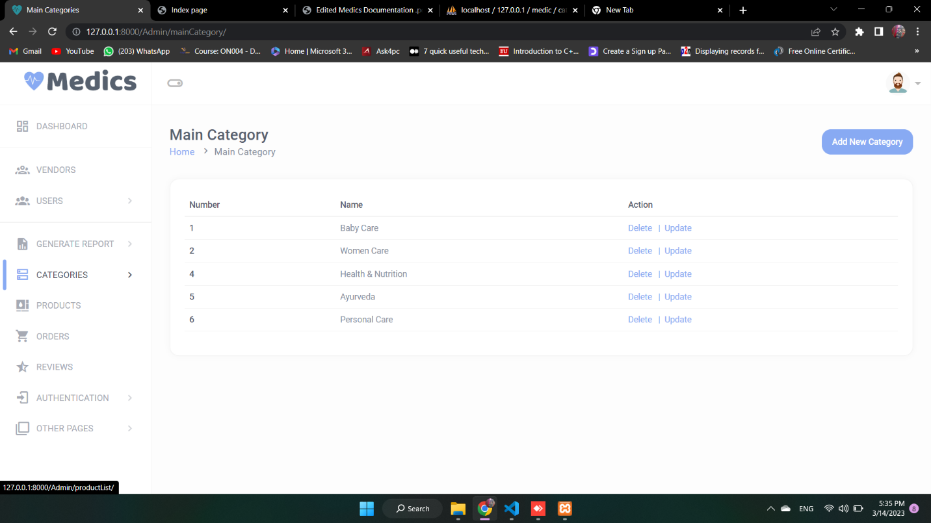**Main Categories**

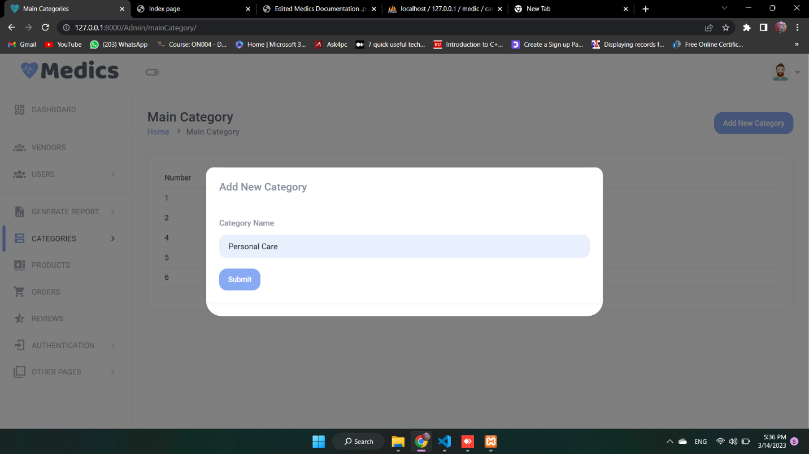**Add Main Category**

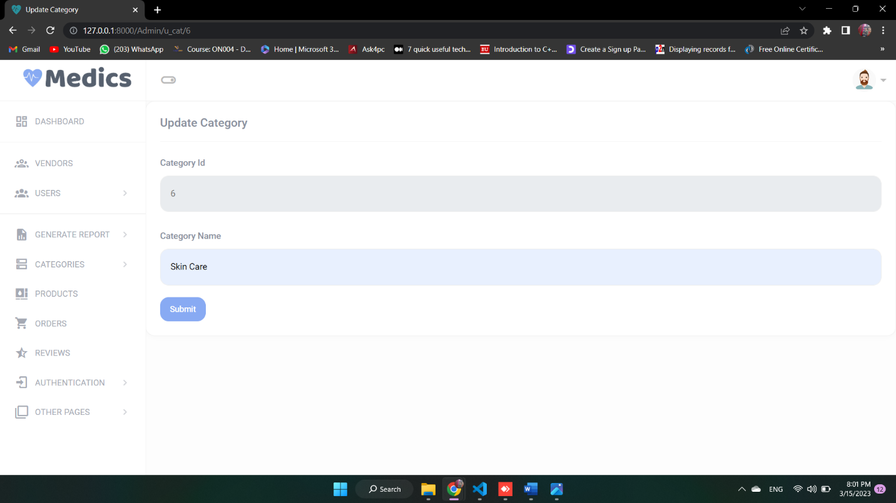**Update Main Category**

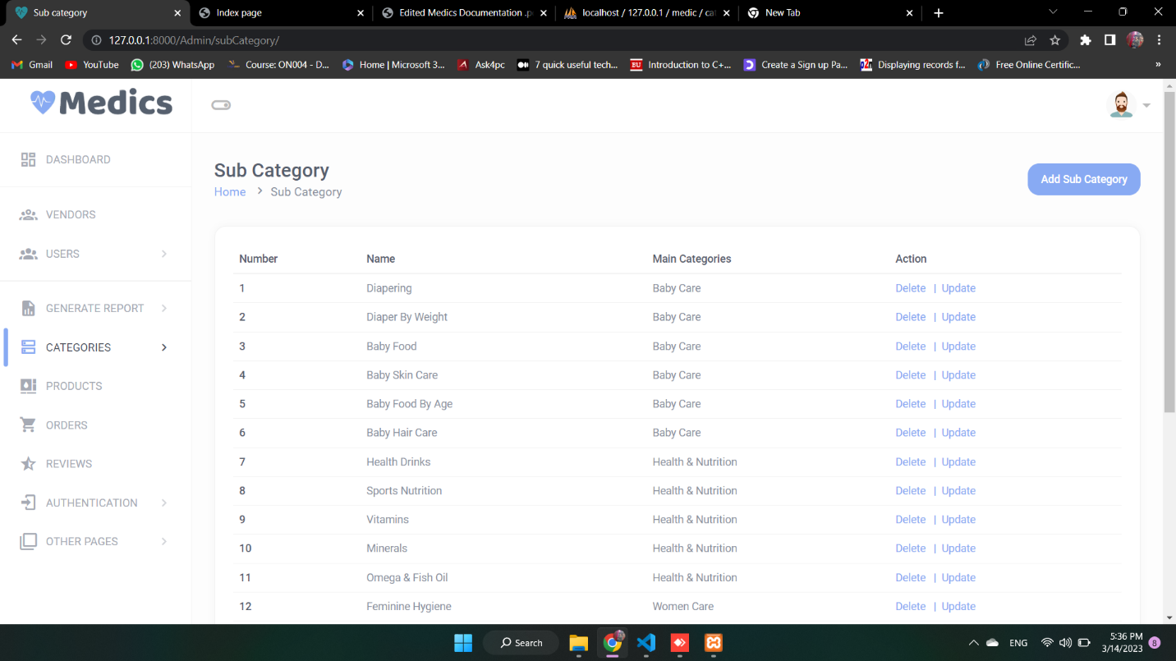**Sub Categories**

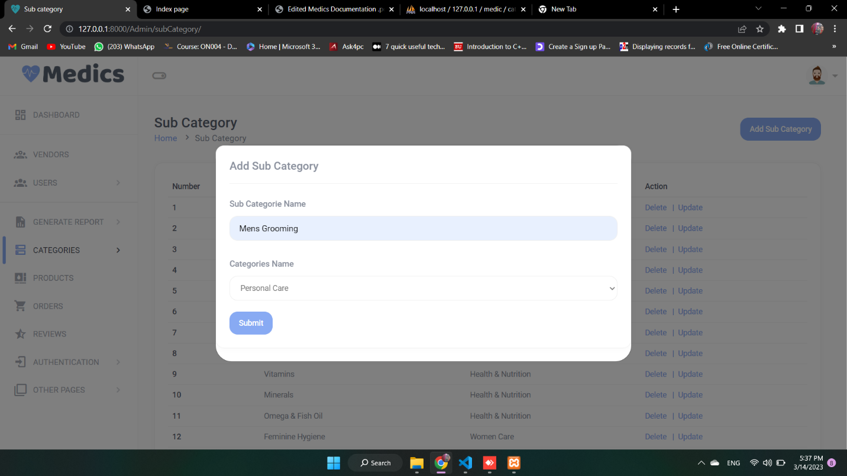**Add Sub Category**

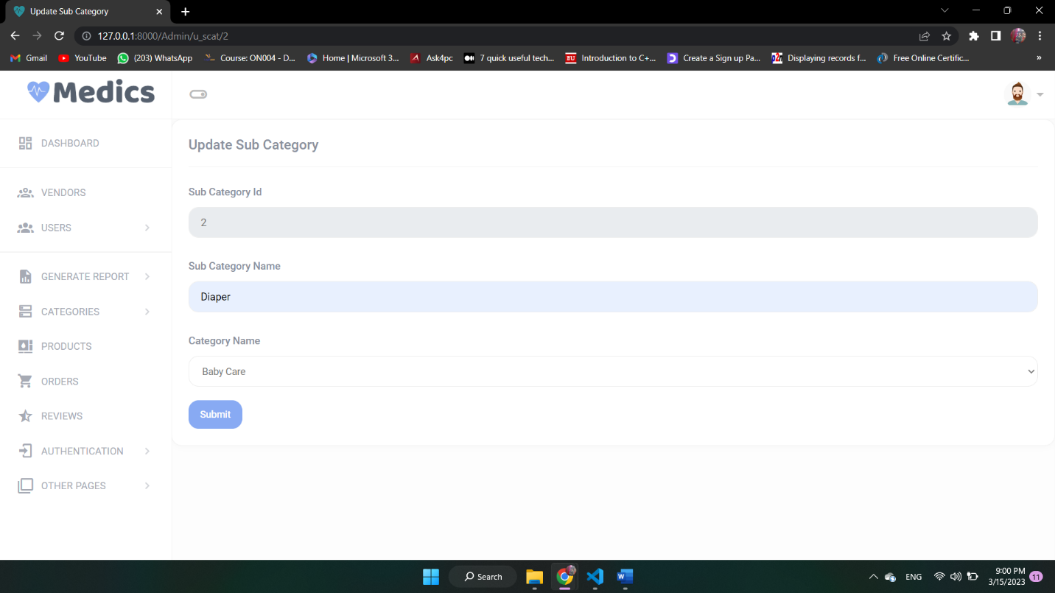**Update Sub Category**

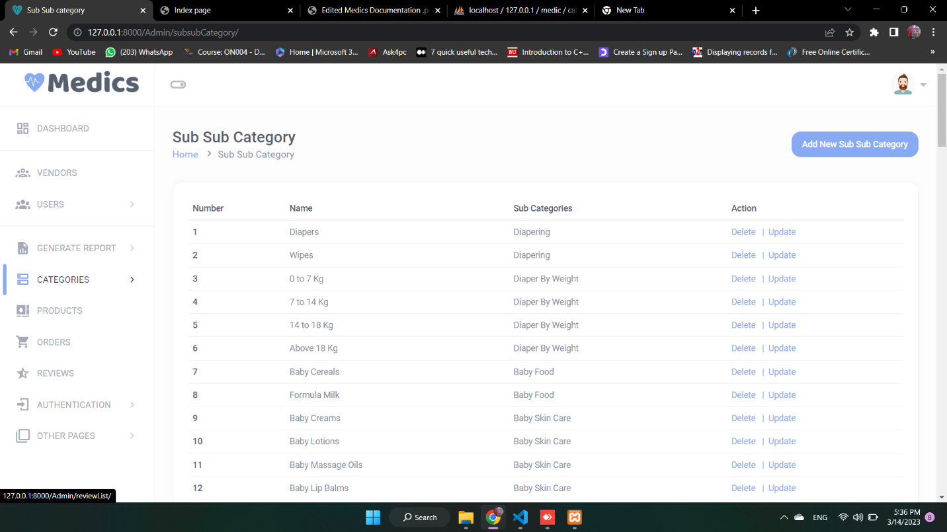**Sub Sub Categories**

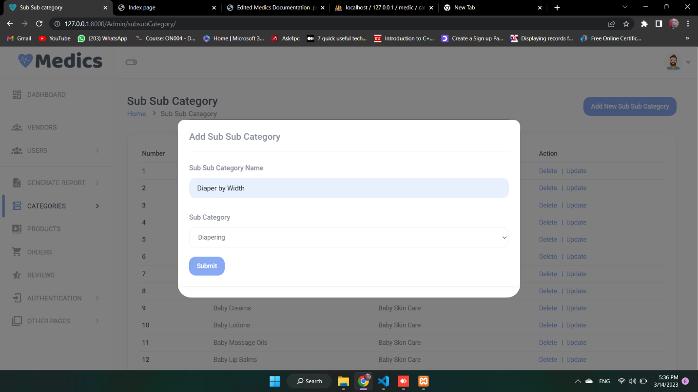**Add Sub Sub Category**

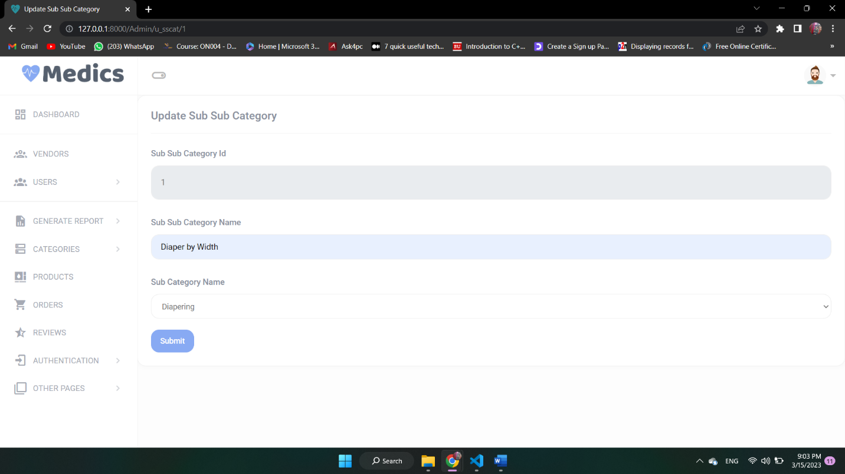**Update Sub Sub Category**

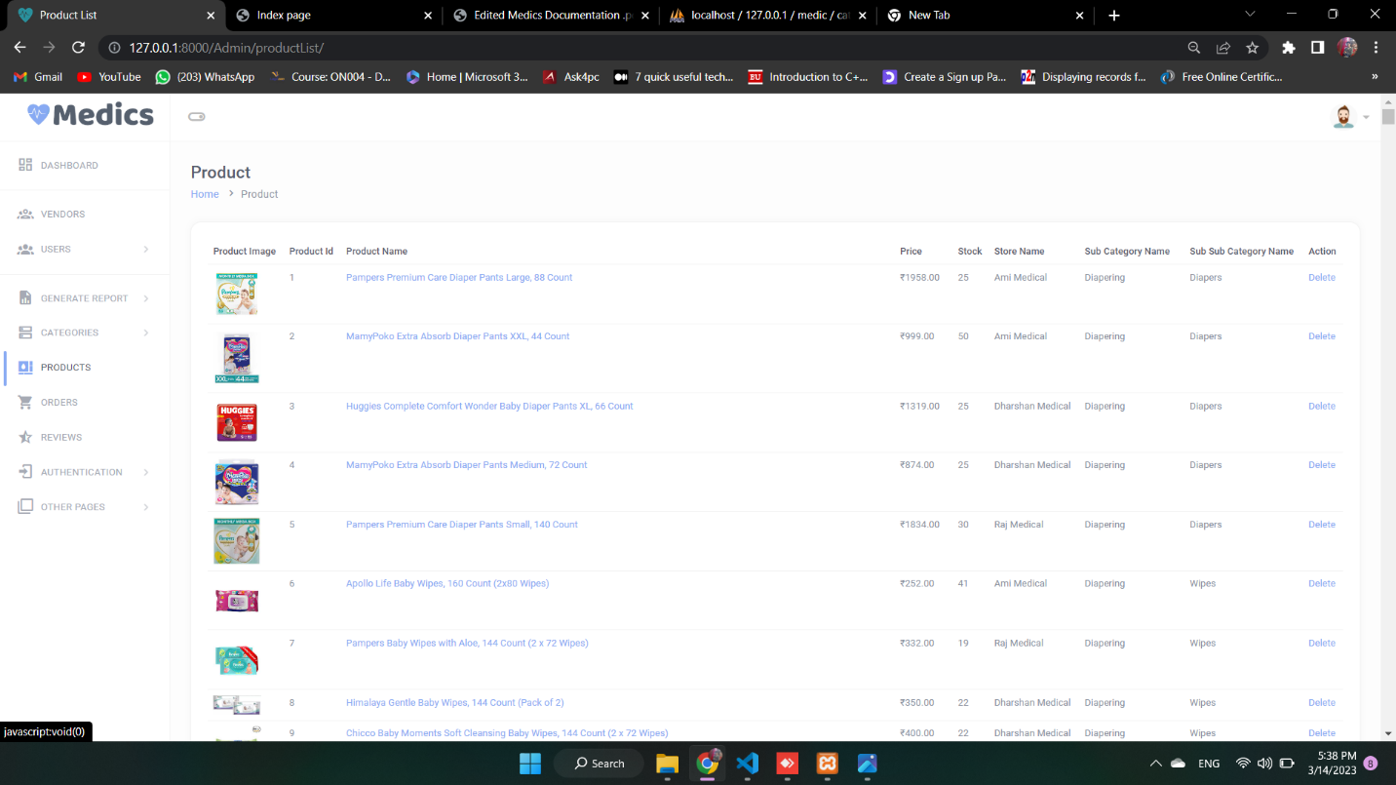**Product**

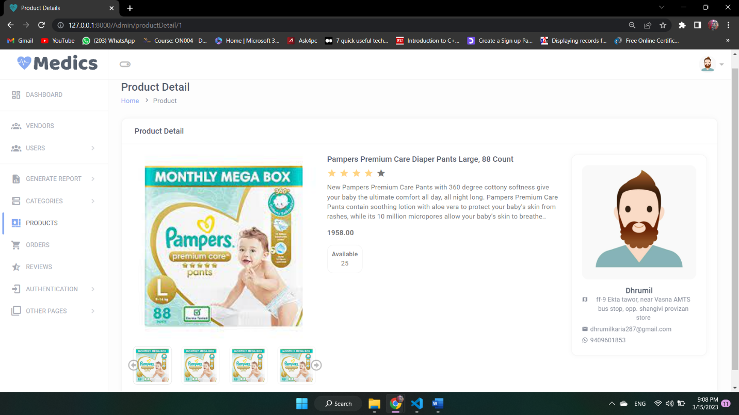**Product Detail**

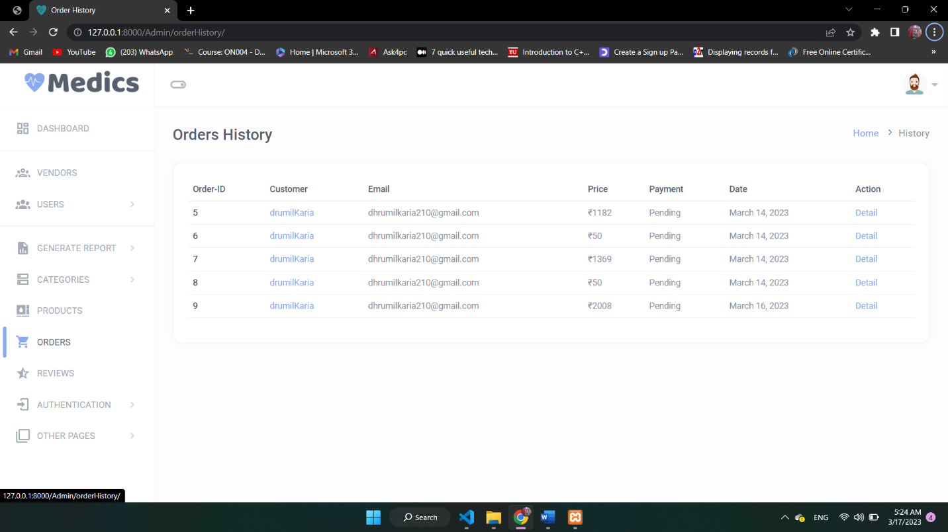**Order**

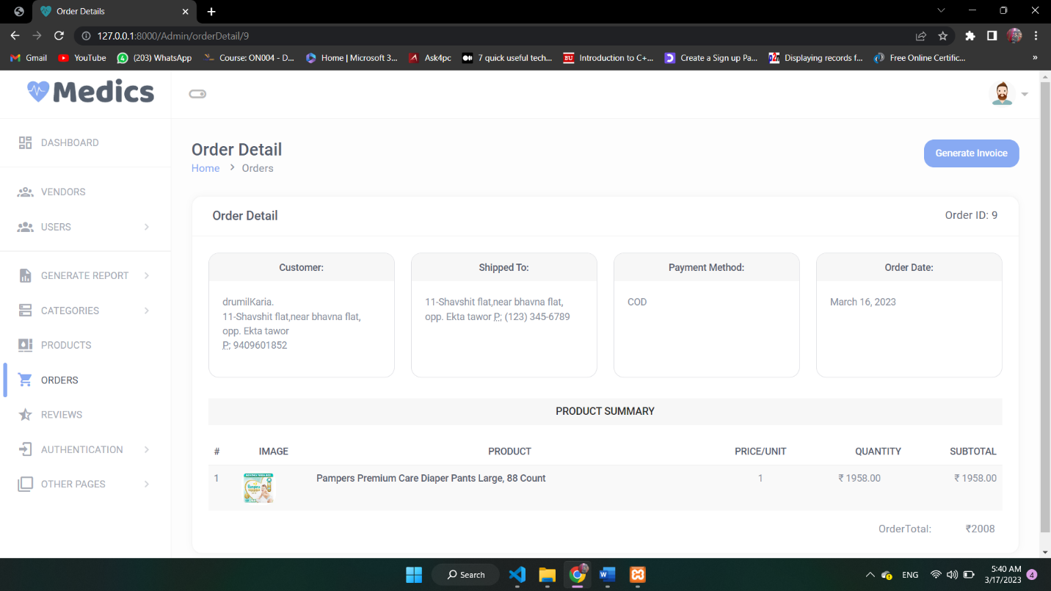 **Order Detail**

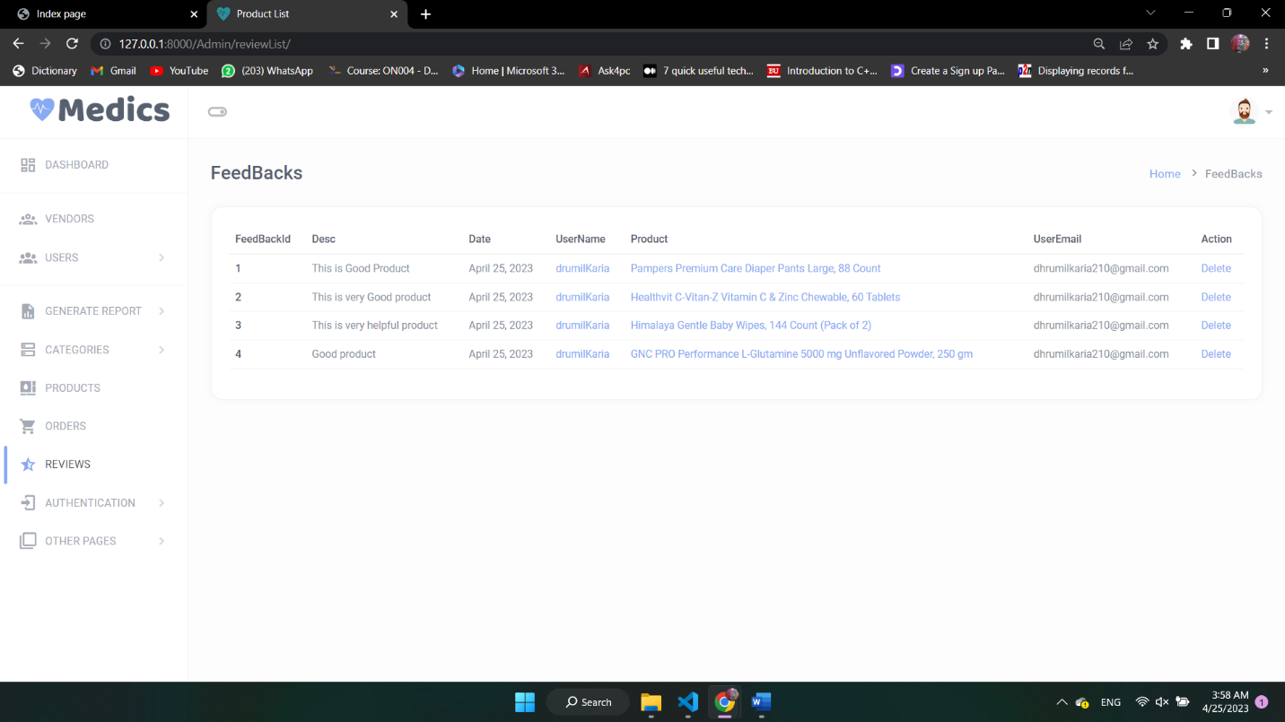**Feedbacks**

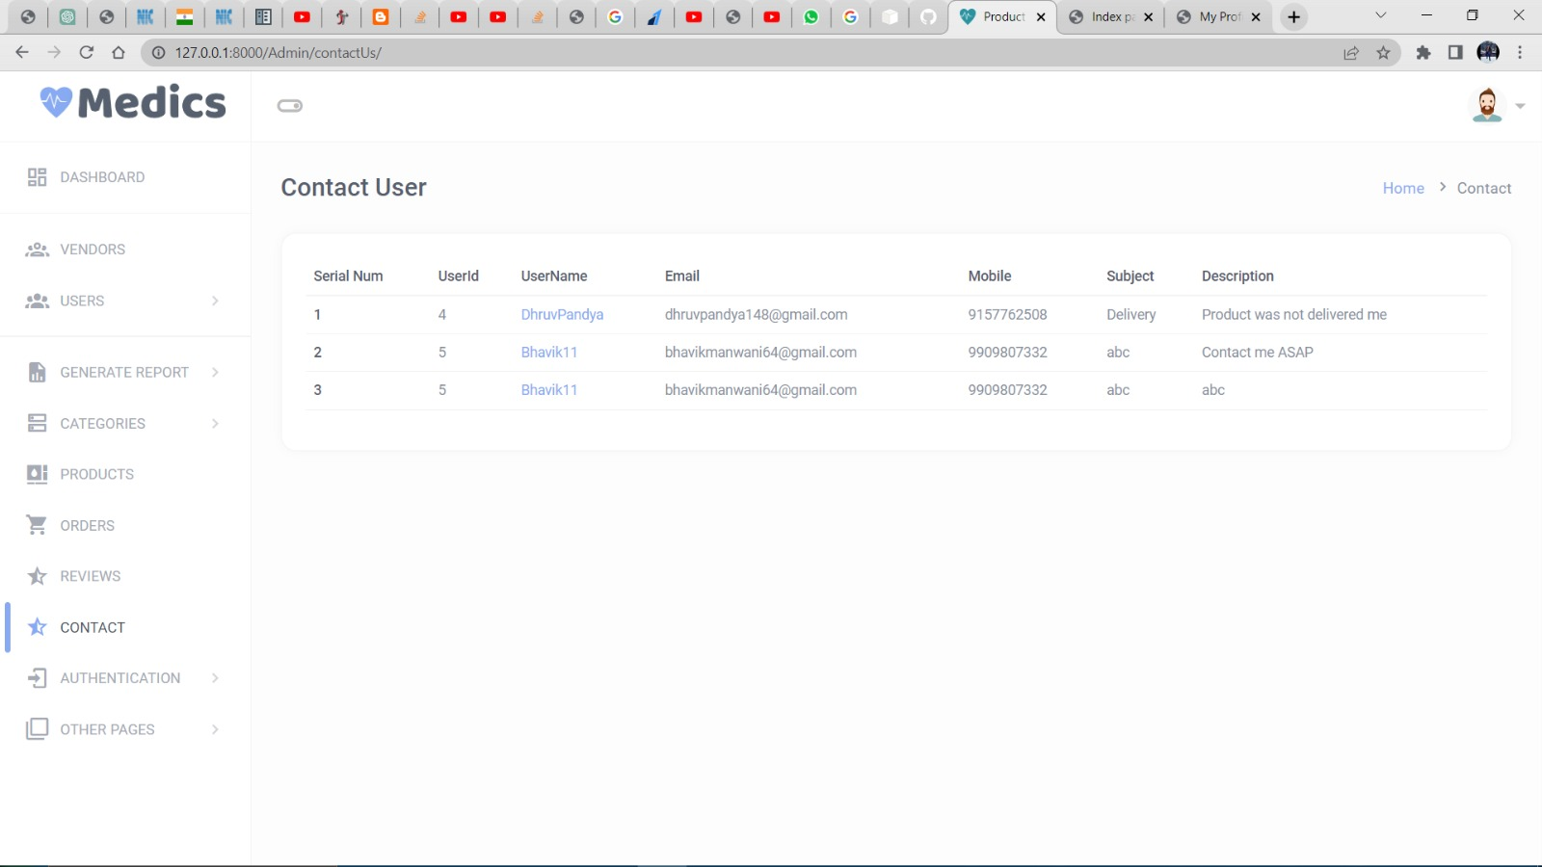**Contact Us**

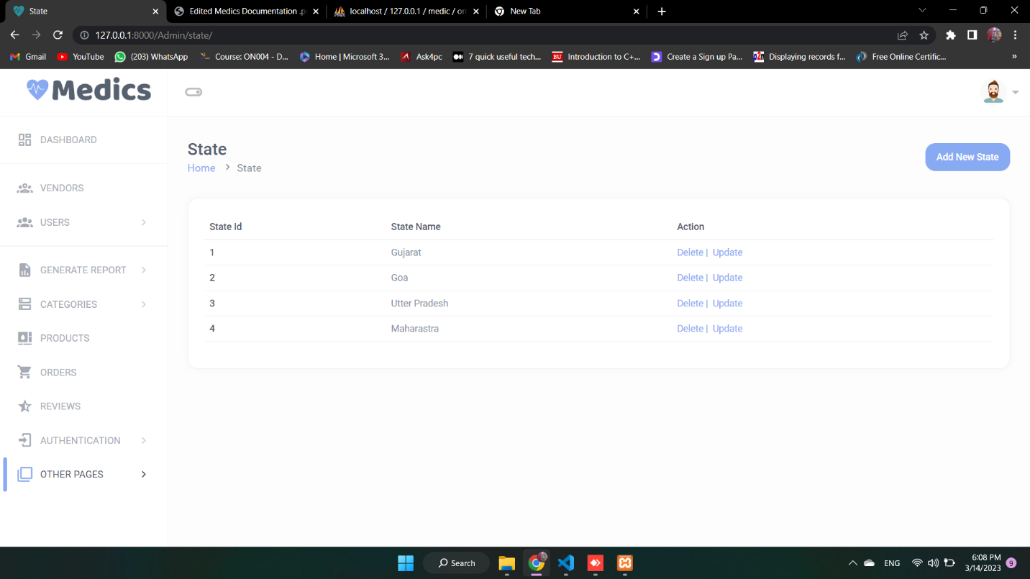**State**

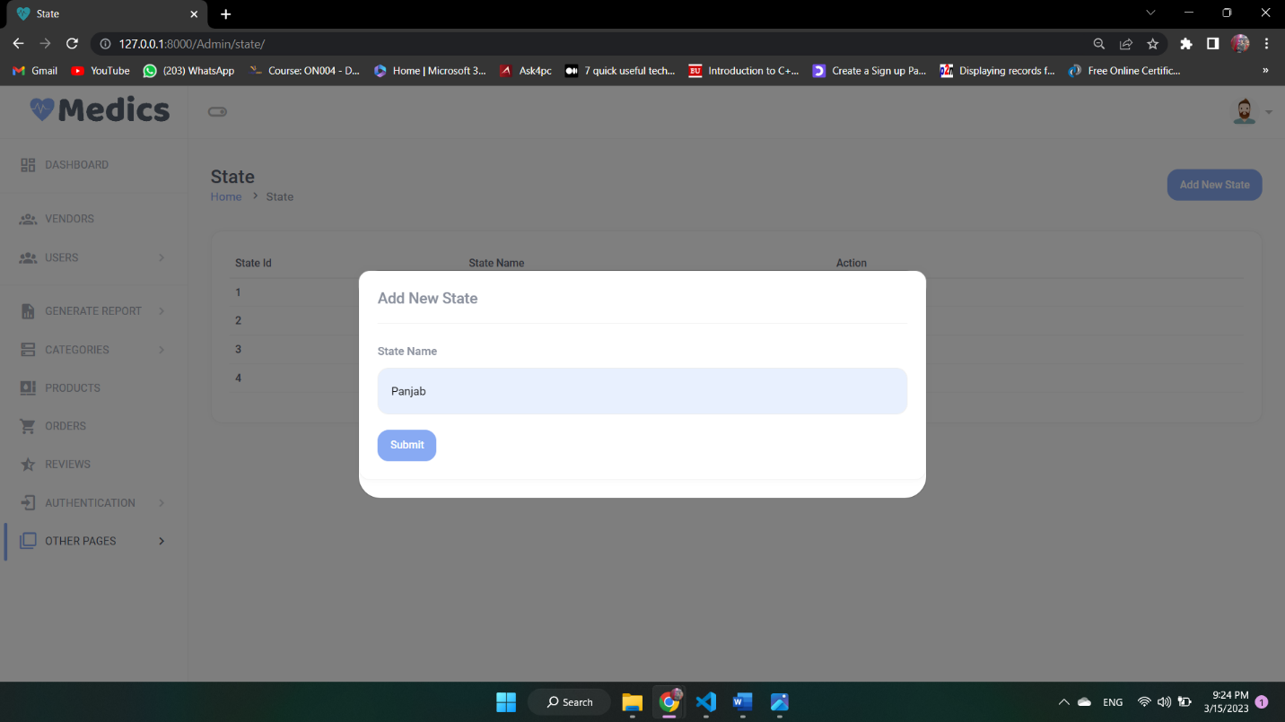**Add State**

**Update State** 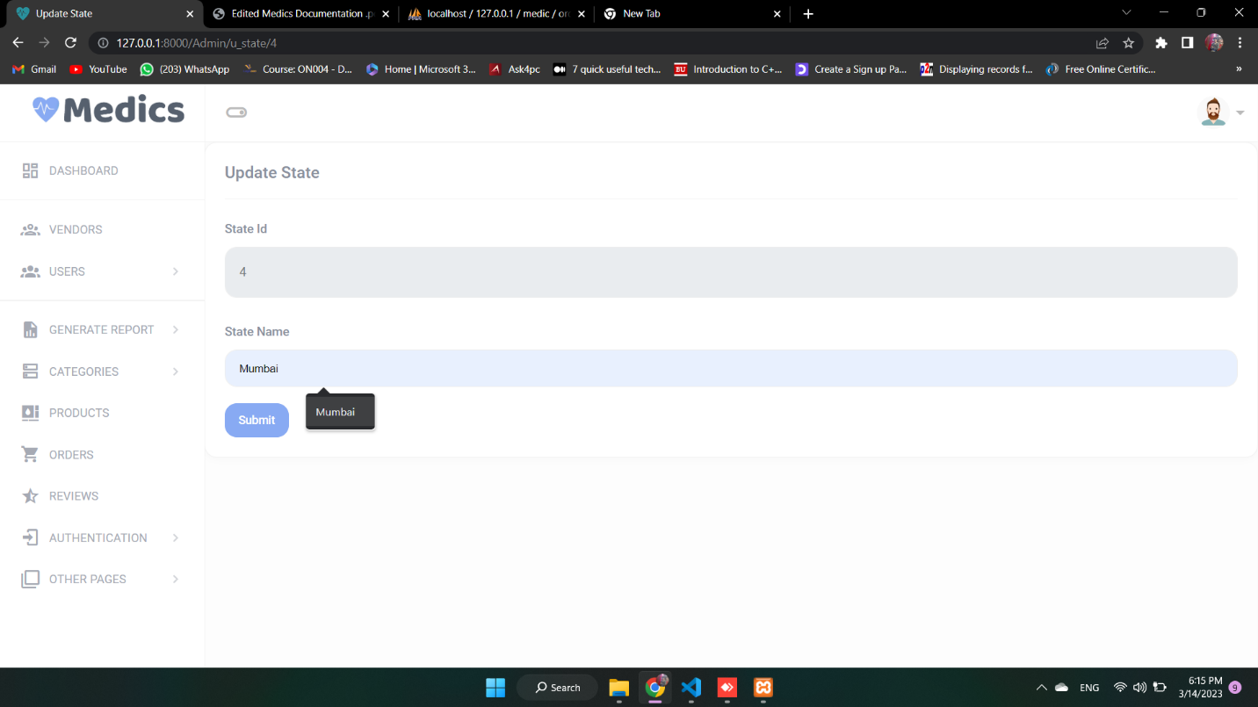

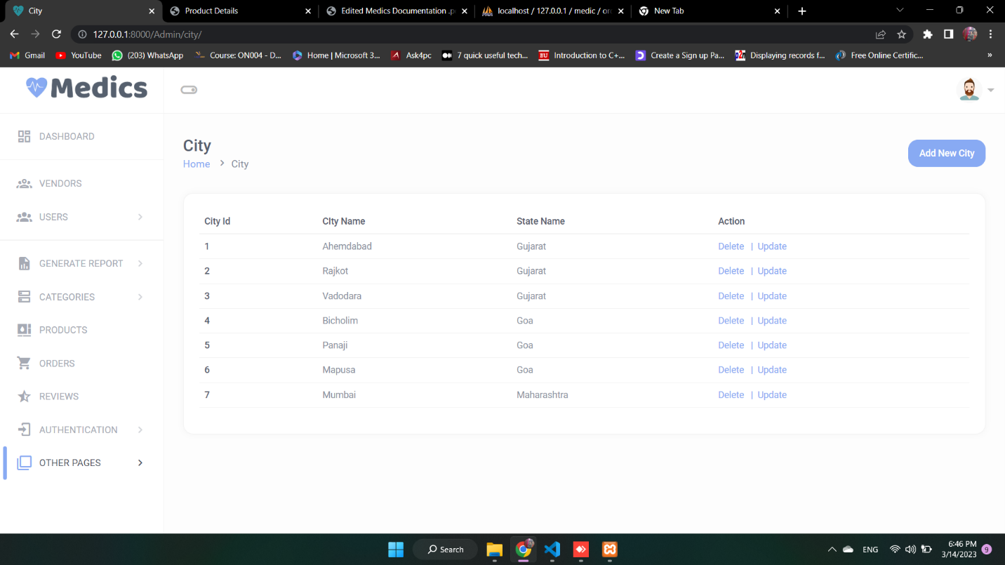**City**

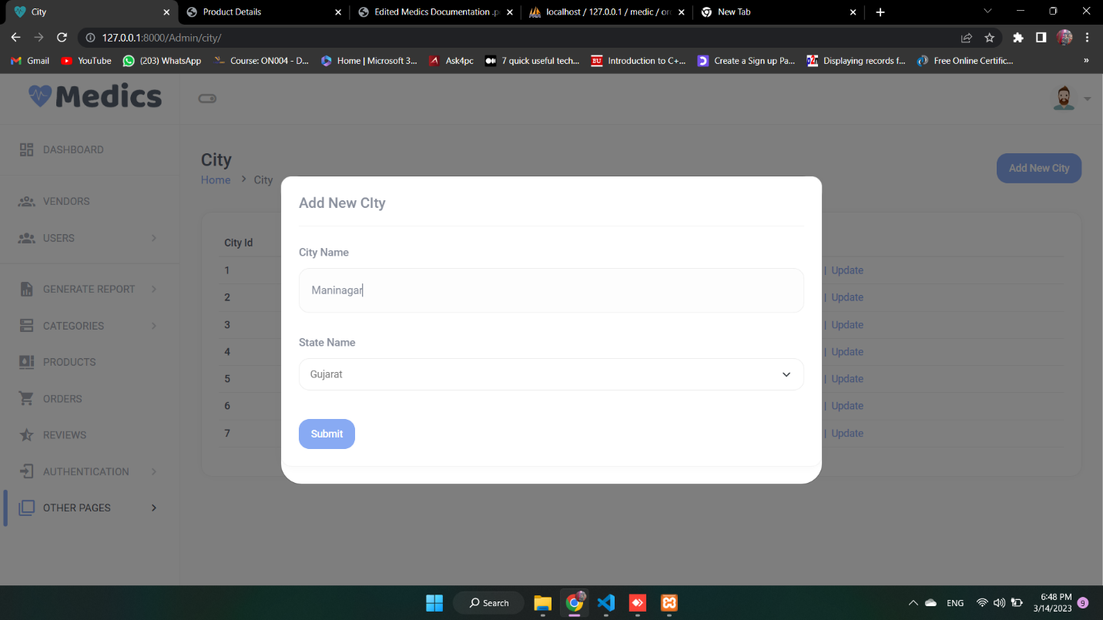**Add City**

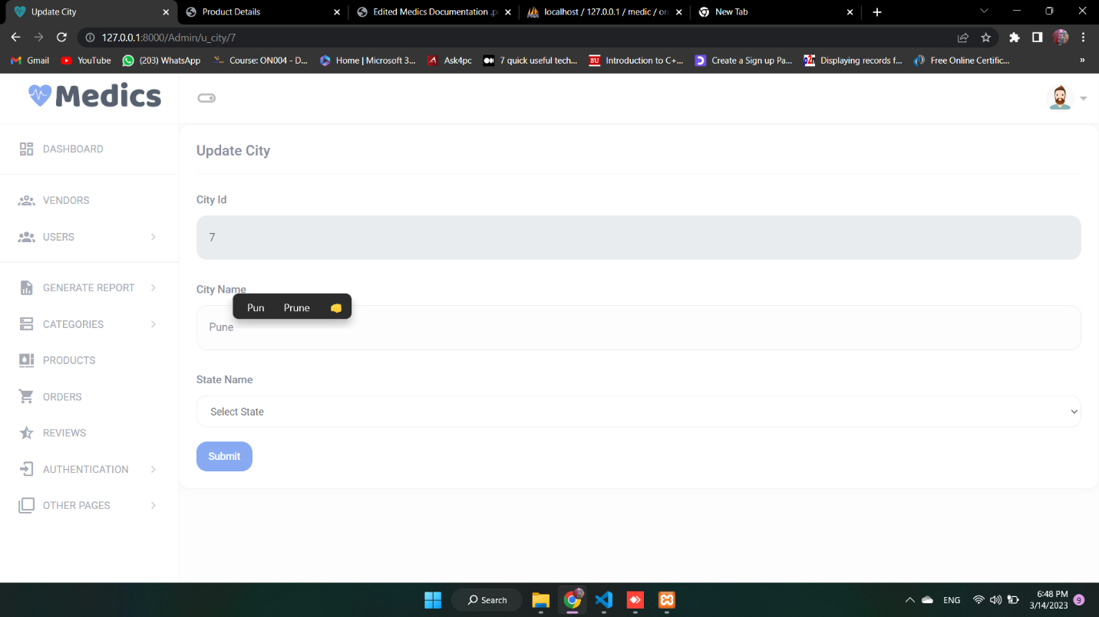**Update City**

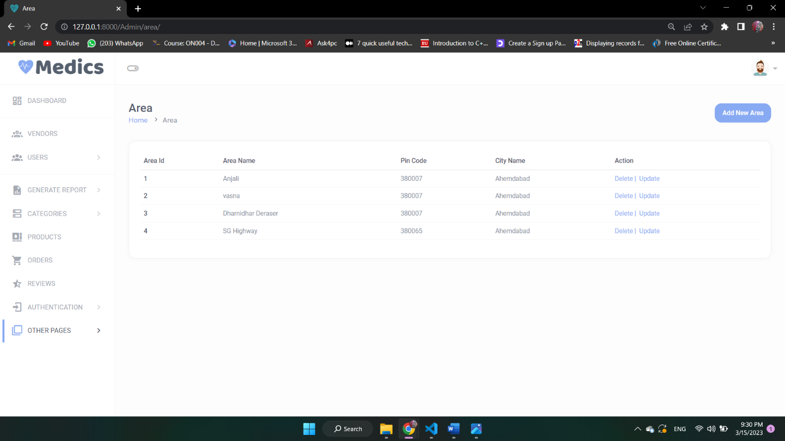**Area**

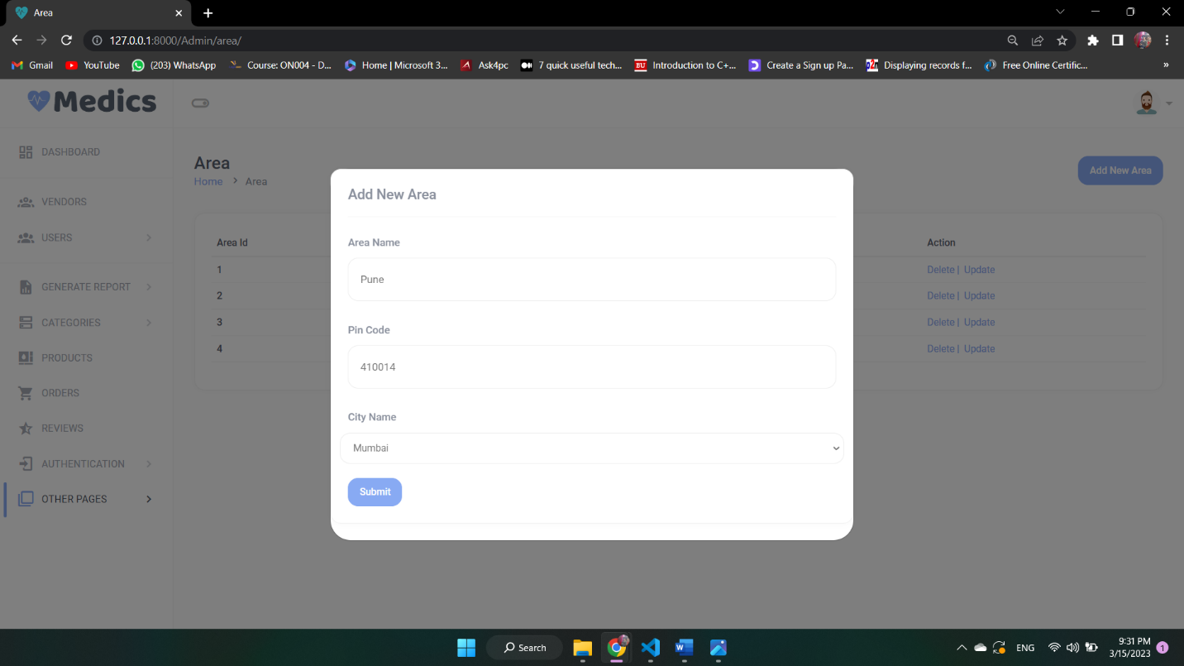**Add Area**

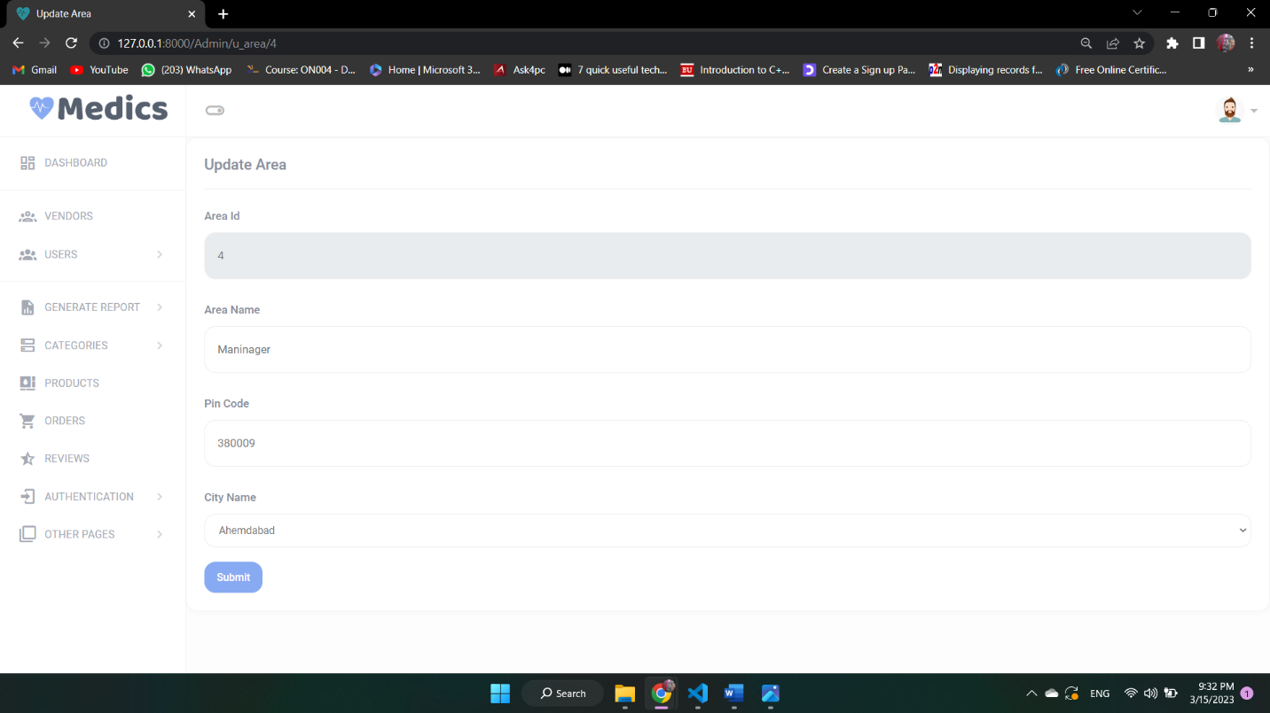**Update Area**

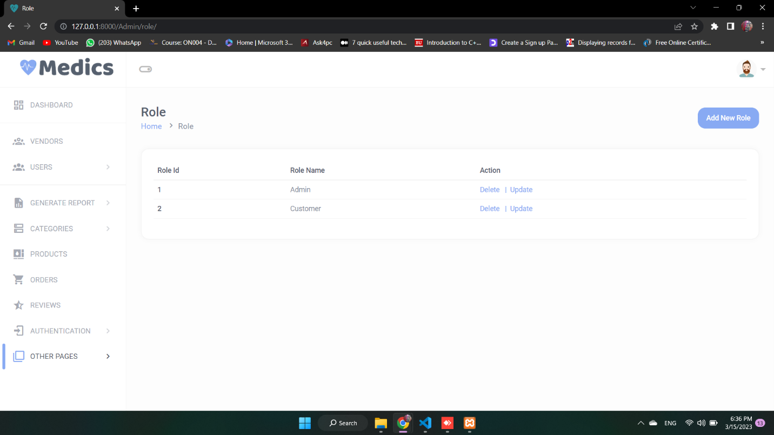**Role**

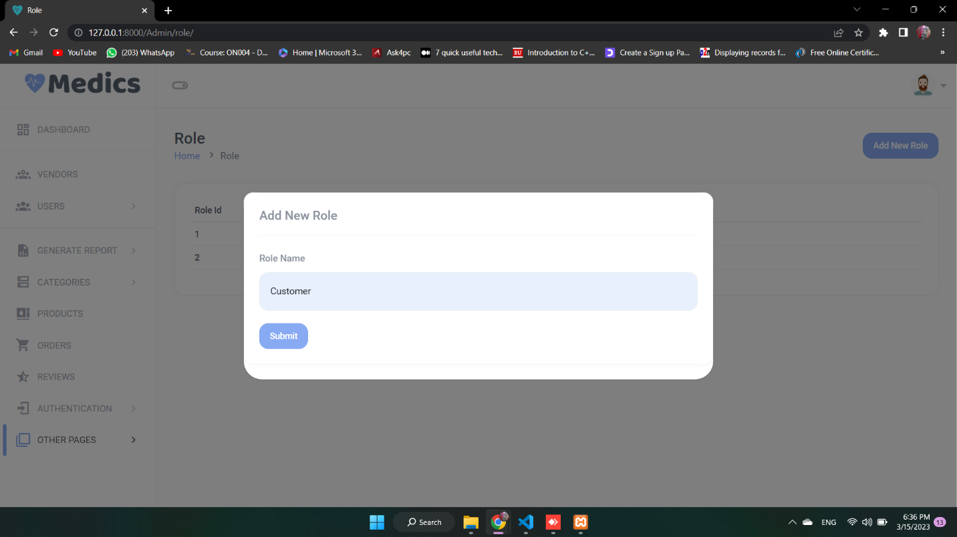**Add Role**

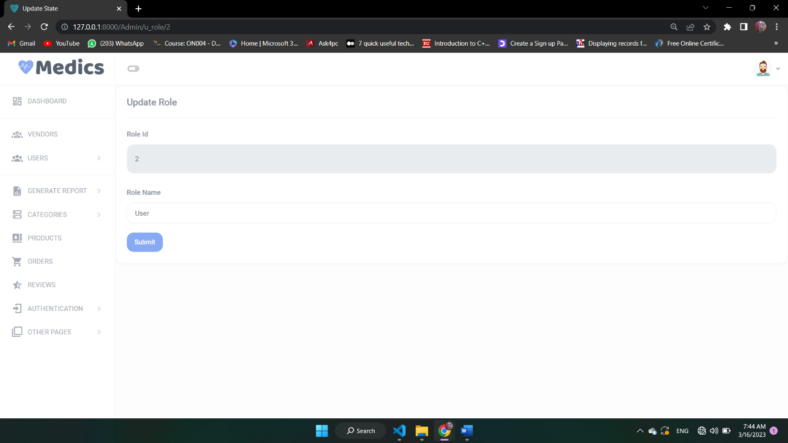**Update Role**

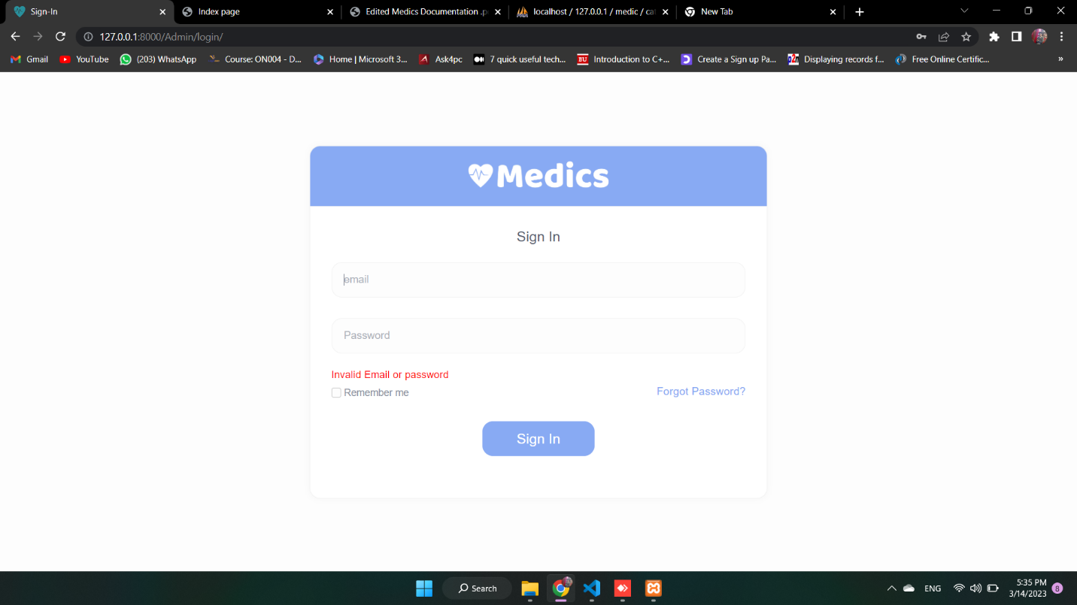**Vendor Login Page**

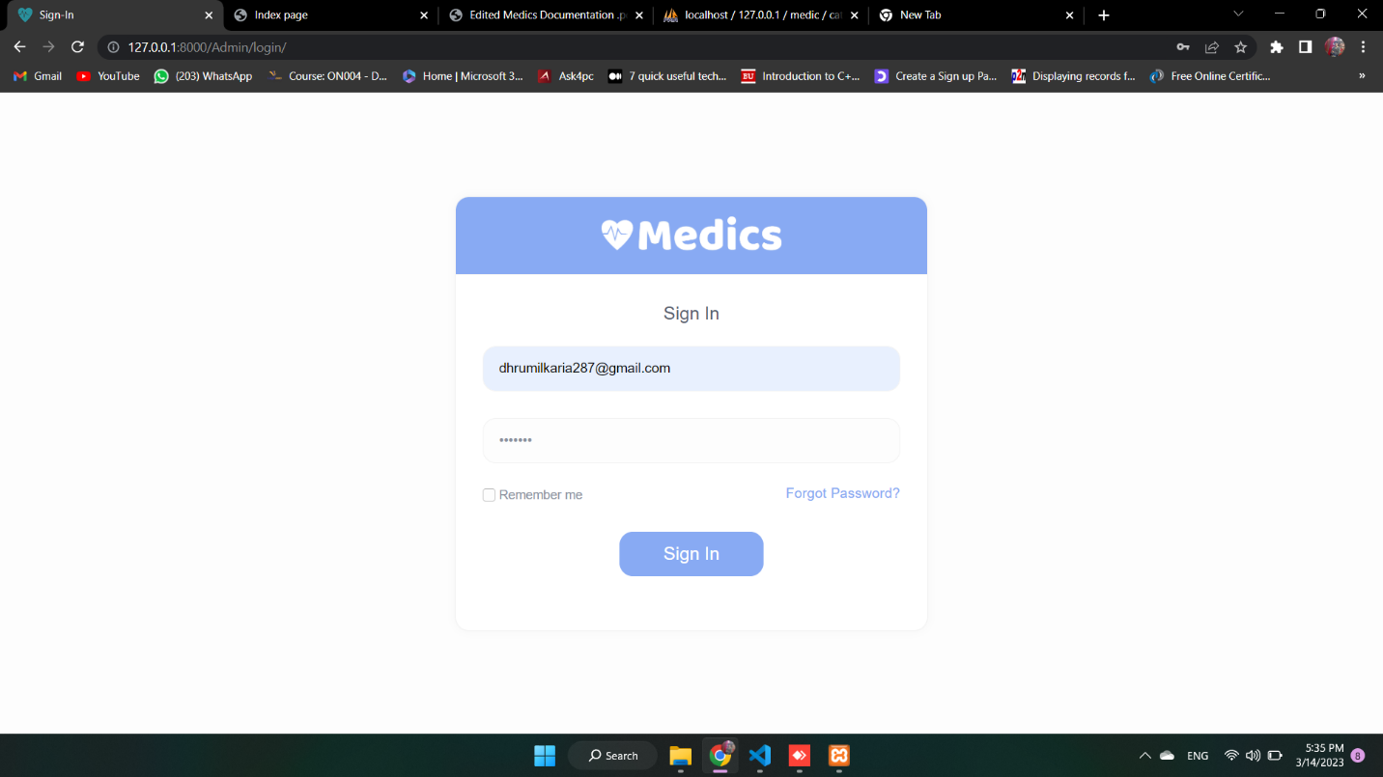**Login Successfully**

** Vendor Forgot Password Page**

**Vendor Send OTP & New Password Page **

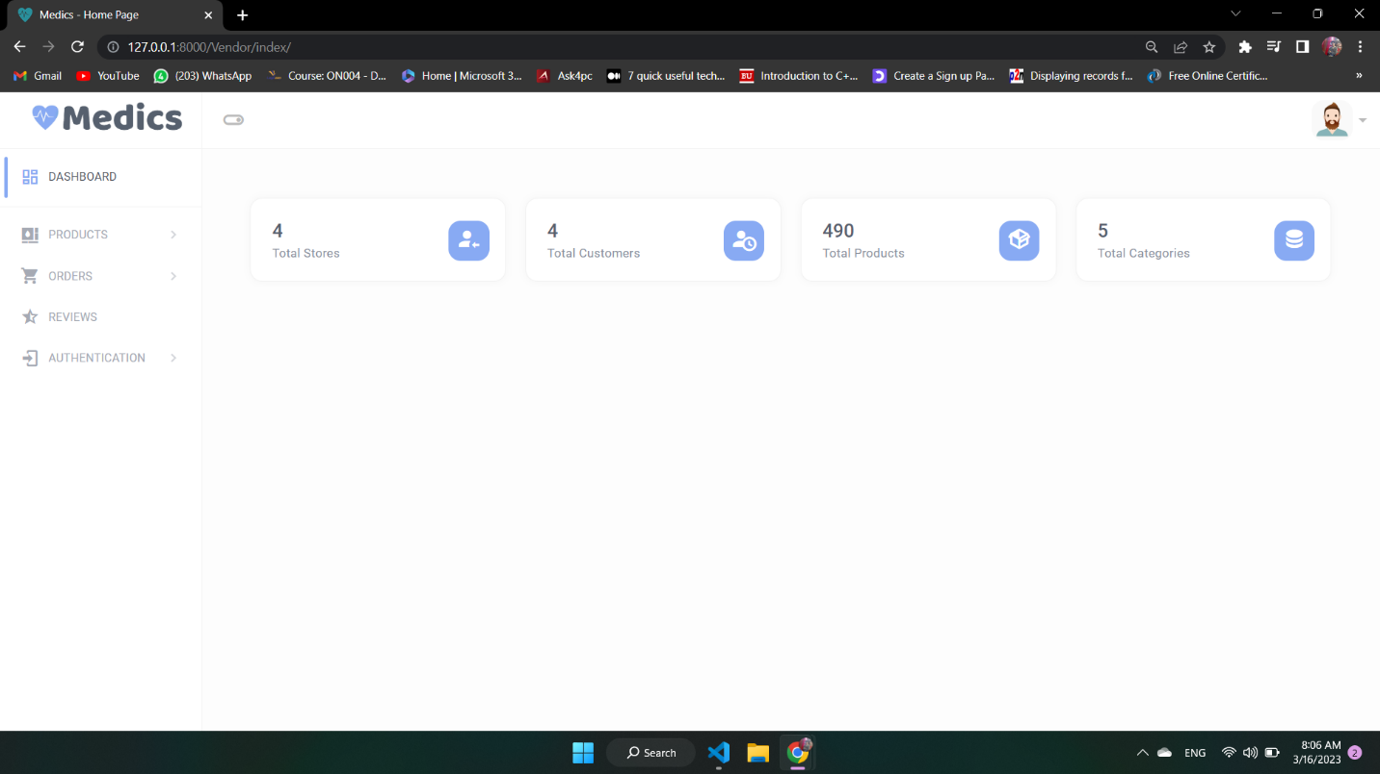**Vendor Dashboard**

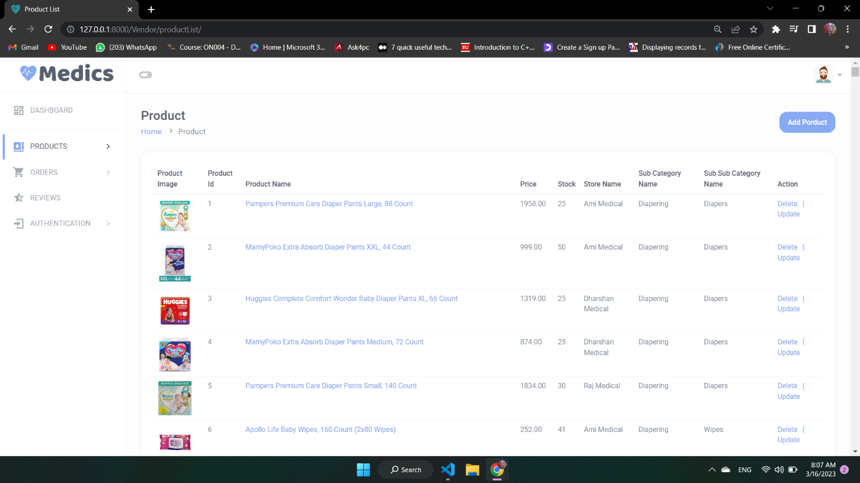**Products**

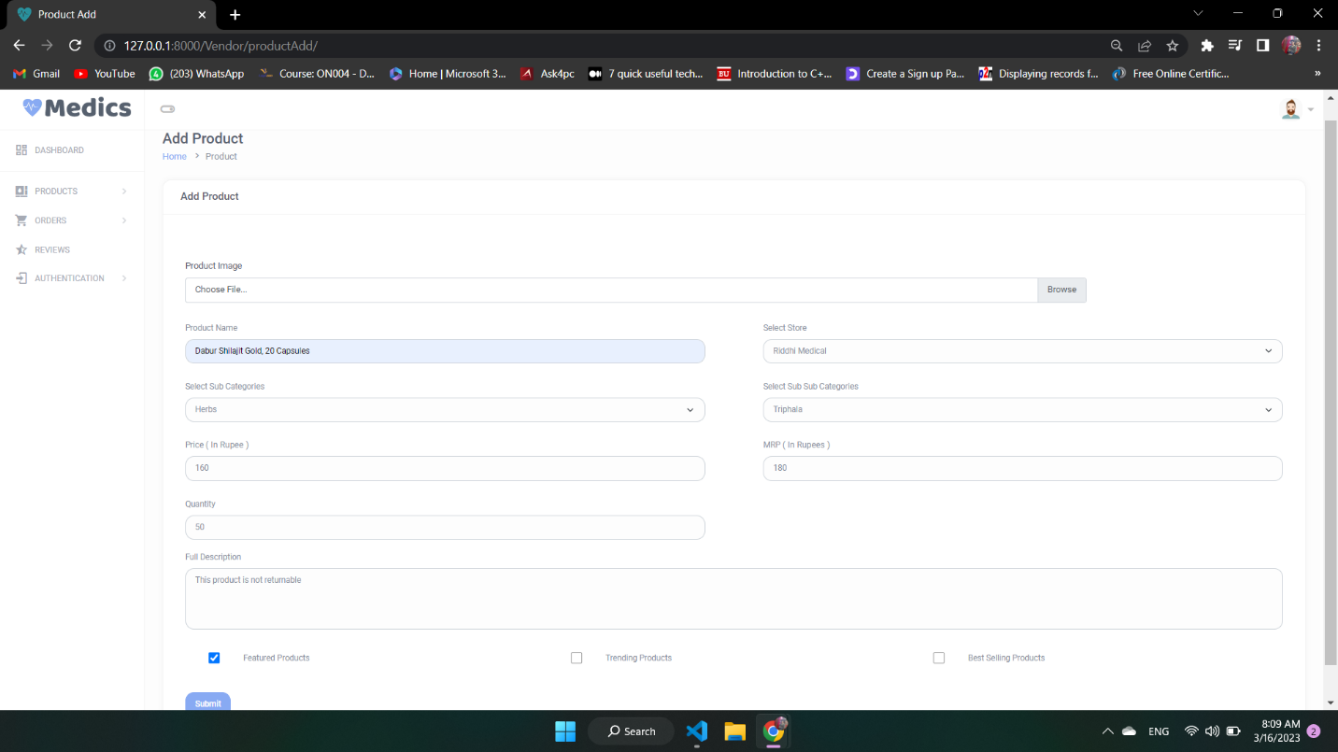**Add Product**

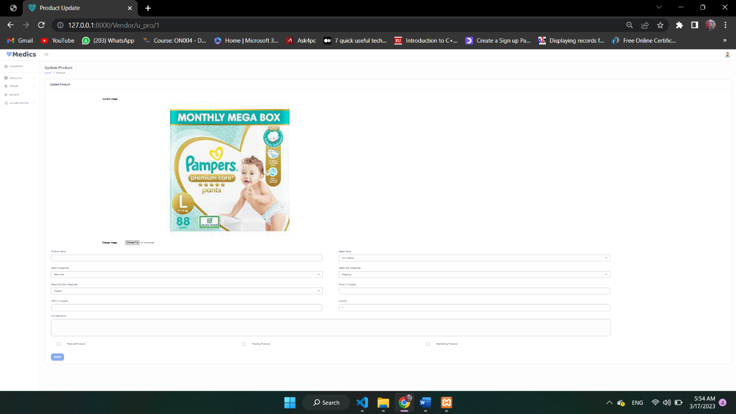**Update Product**

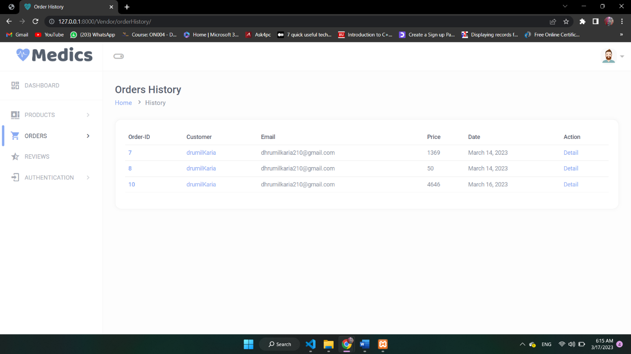**Order**

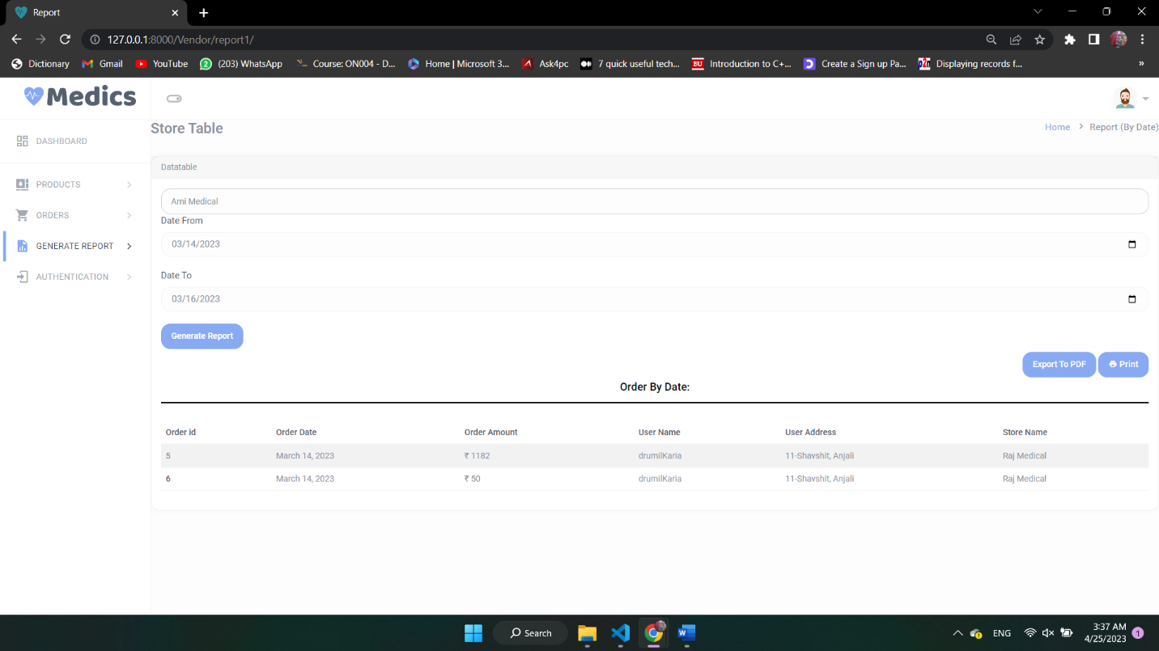**Report By Store**

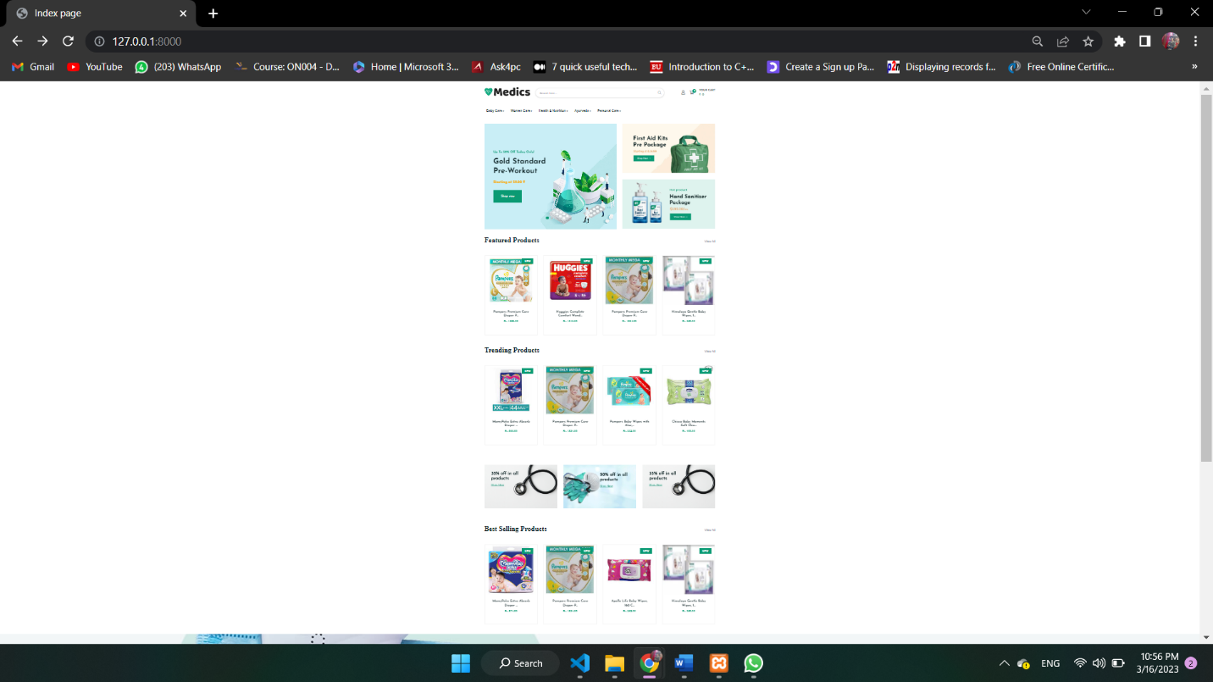**Index page**

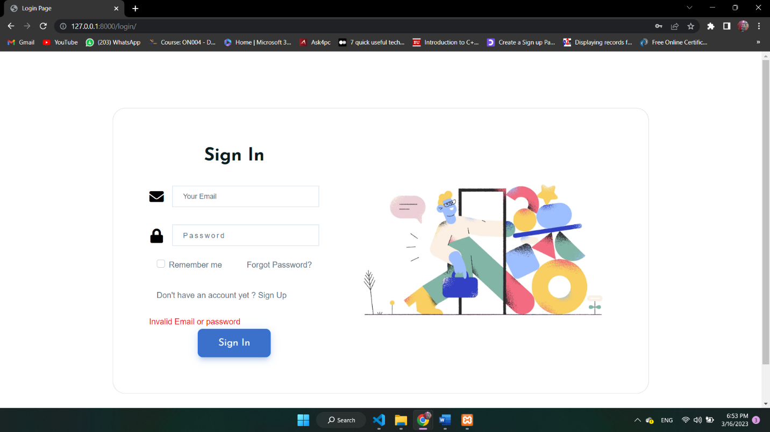**Login for User**

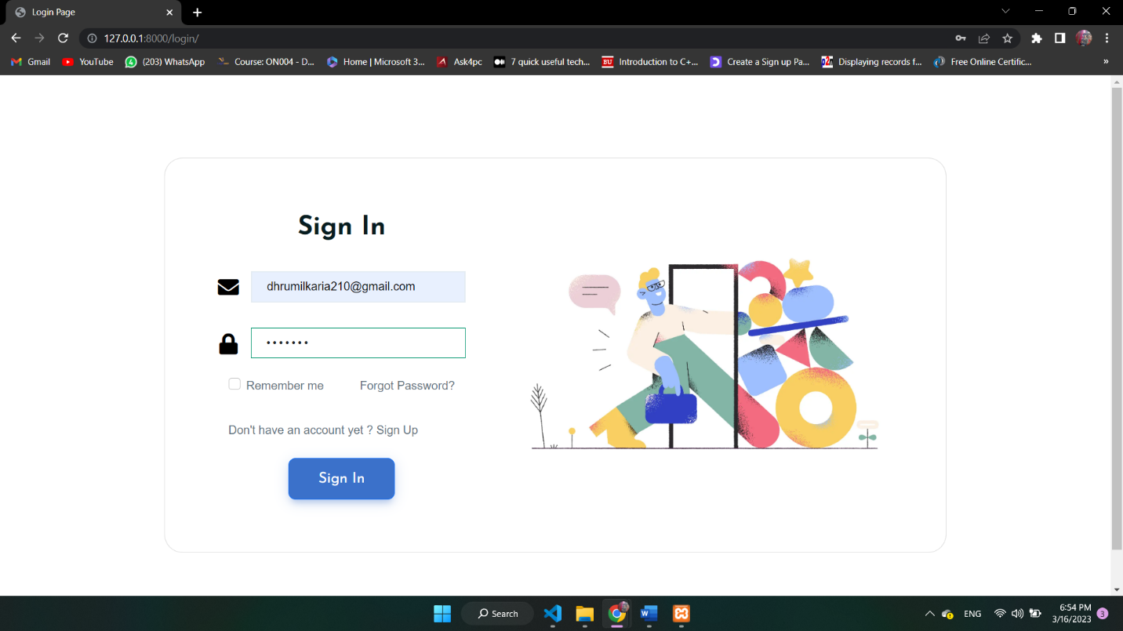**Login Successfully**

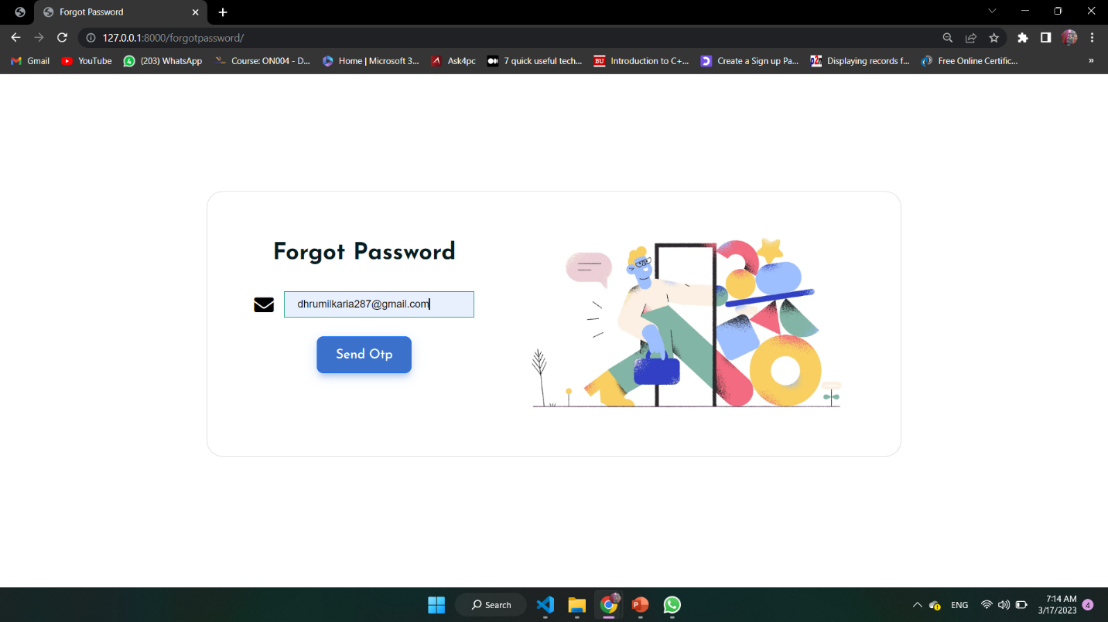**Forgot Password for User**

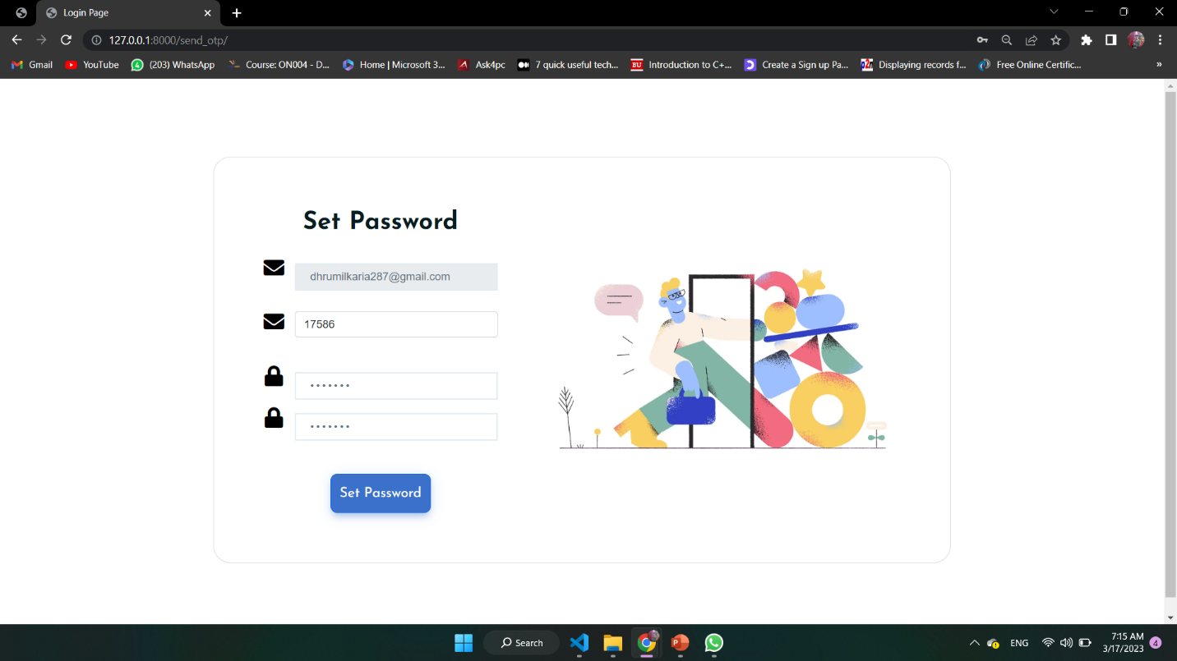**Send OTP & Set New Password**

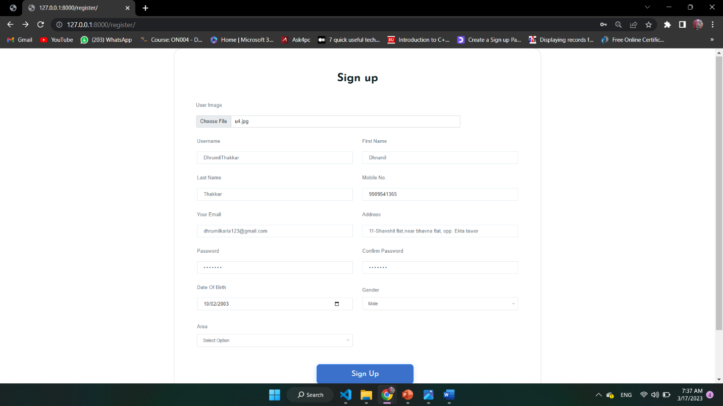 **User Registration**

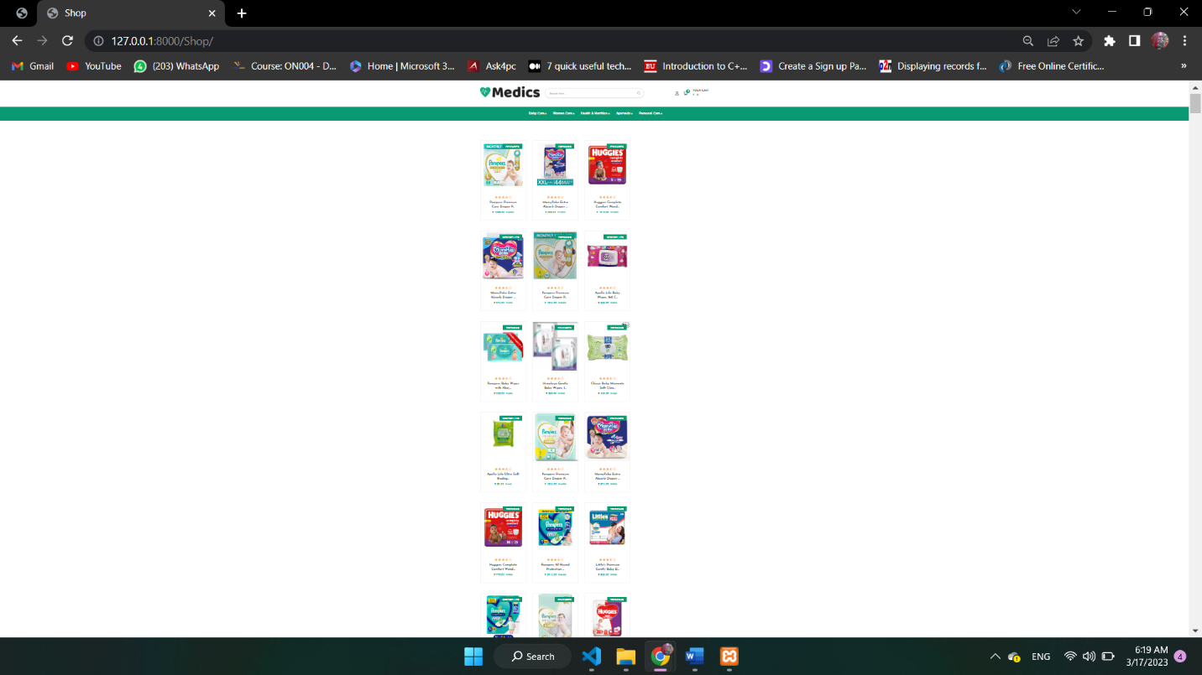**All Product Page**

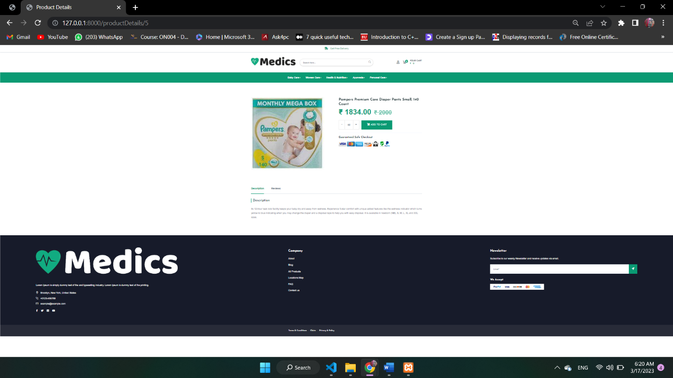**Product Detail Page**

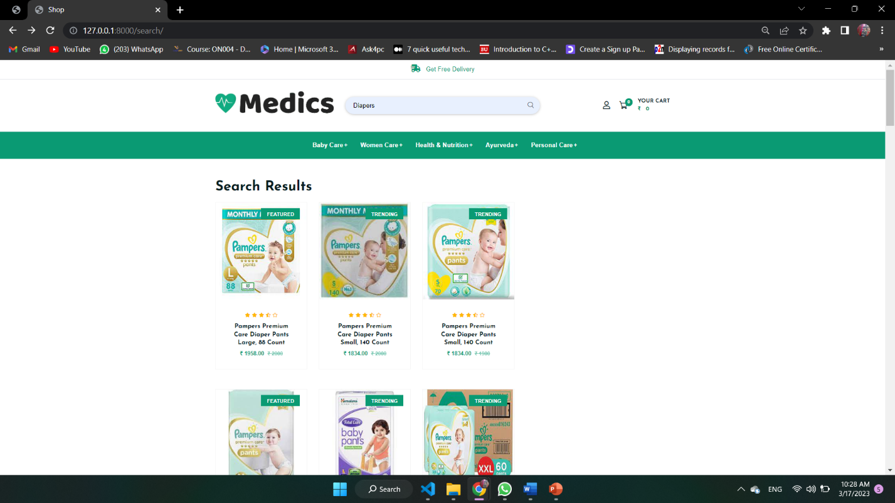**Search Page**

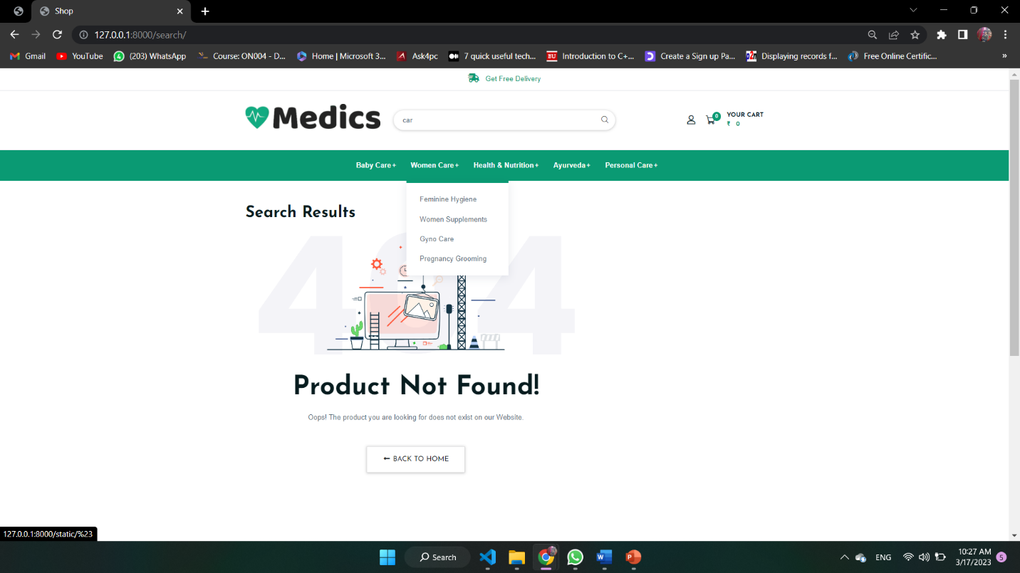**Searching Error**

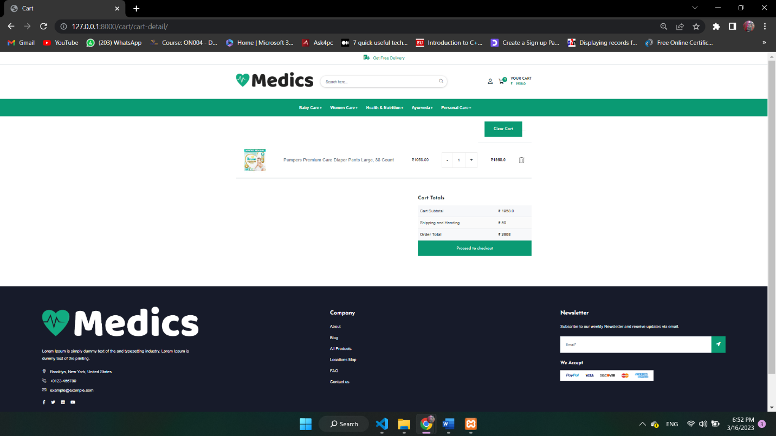**Cart Page**

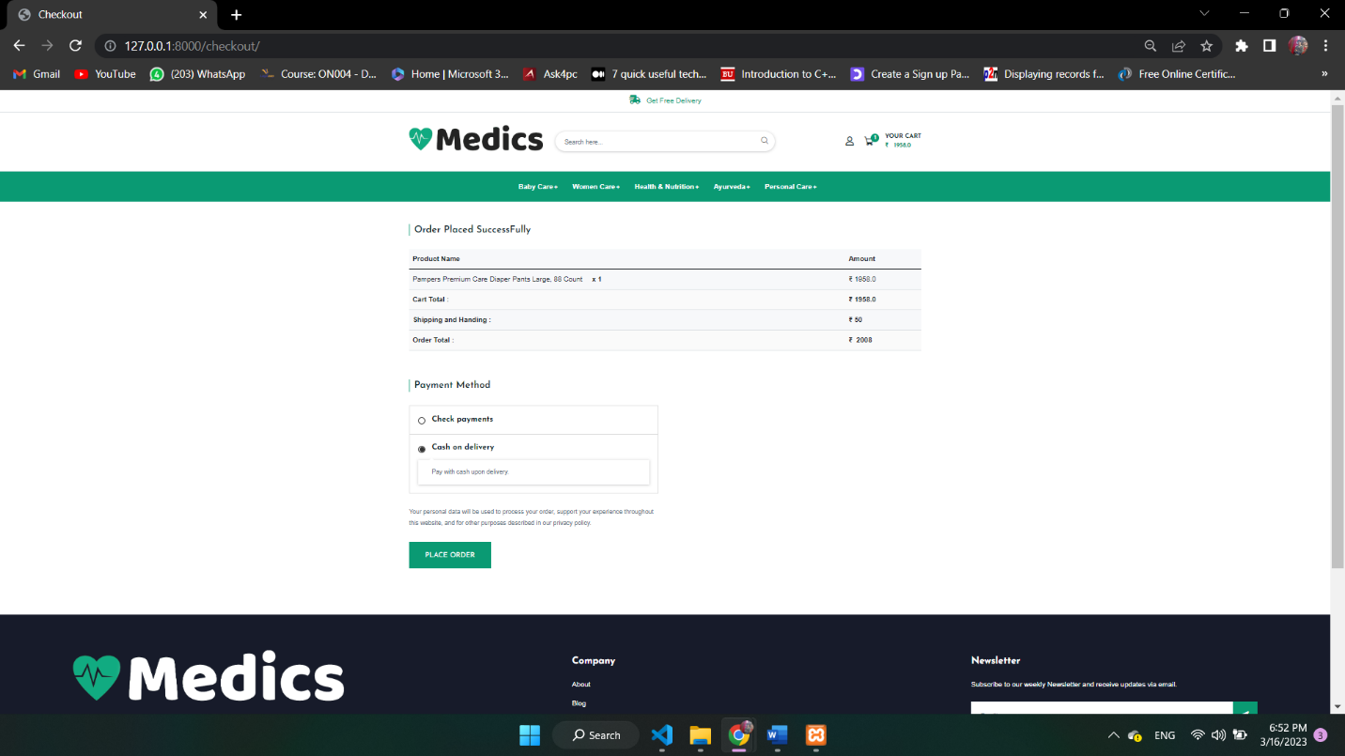**Checkout**

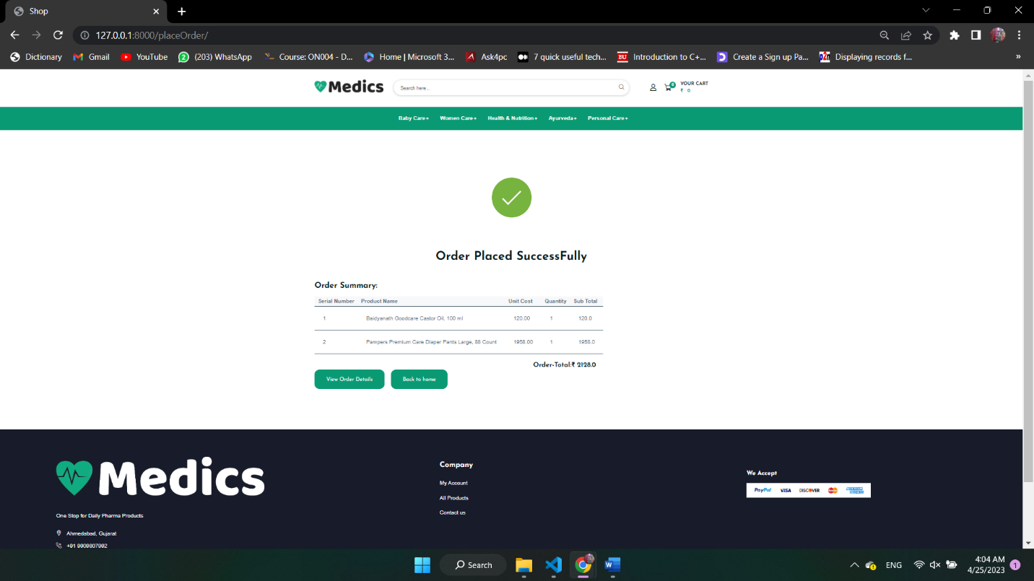**Place Order**

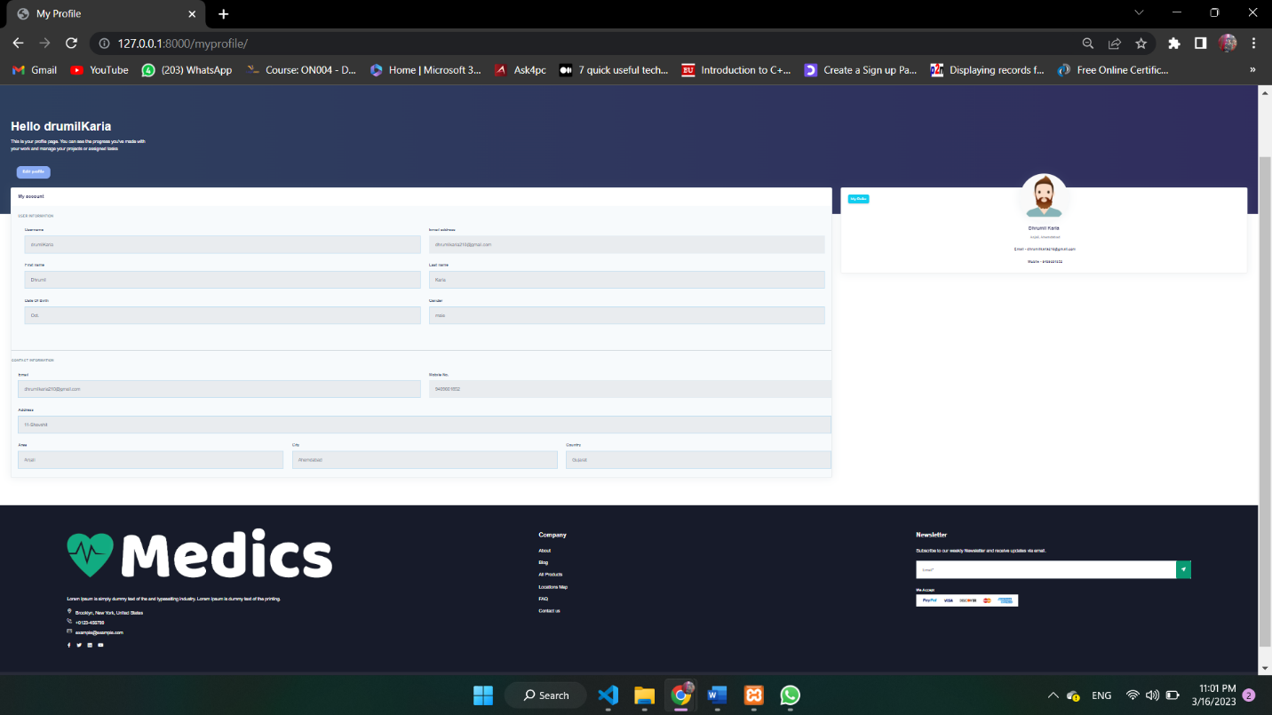**User Detail**

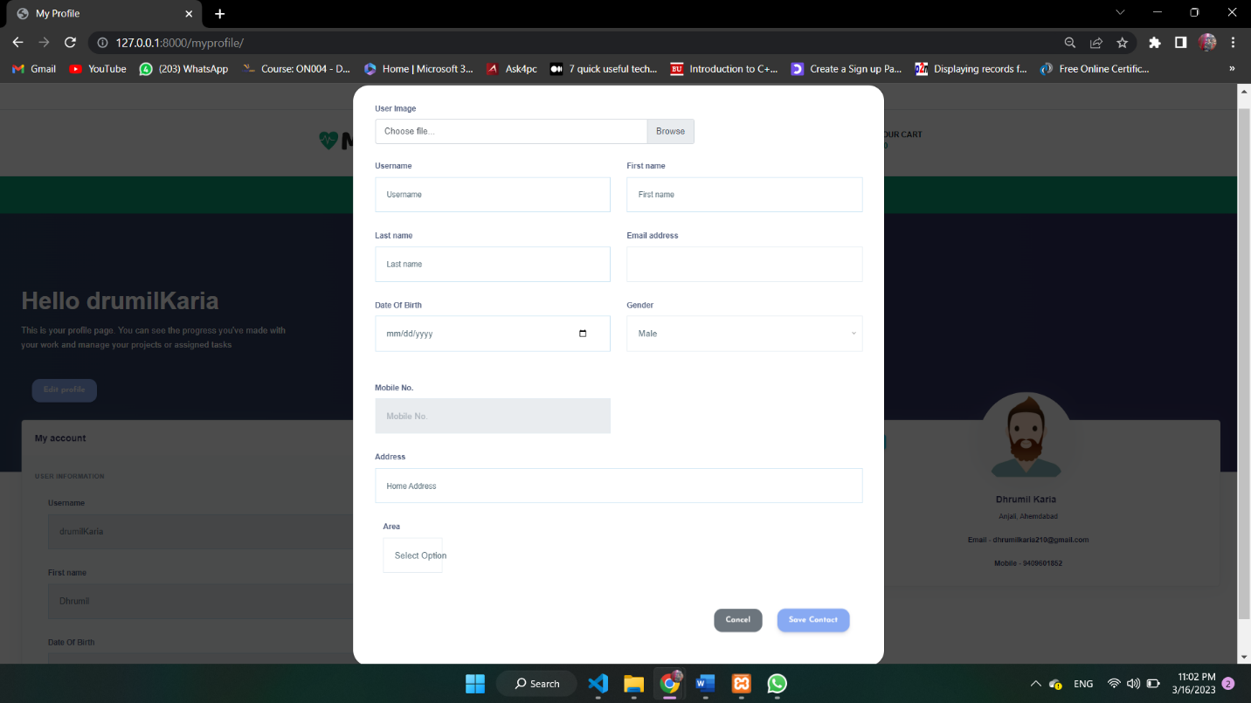**Edit Profile**

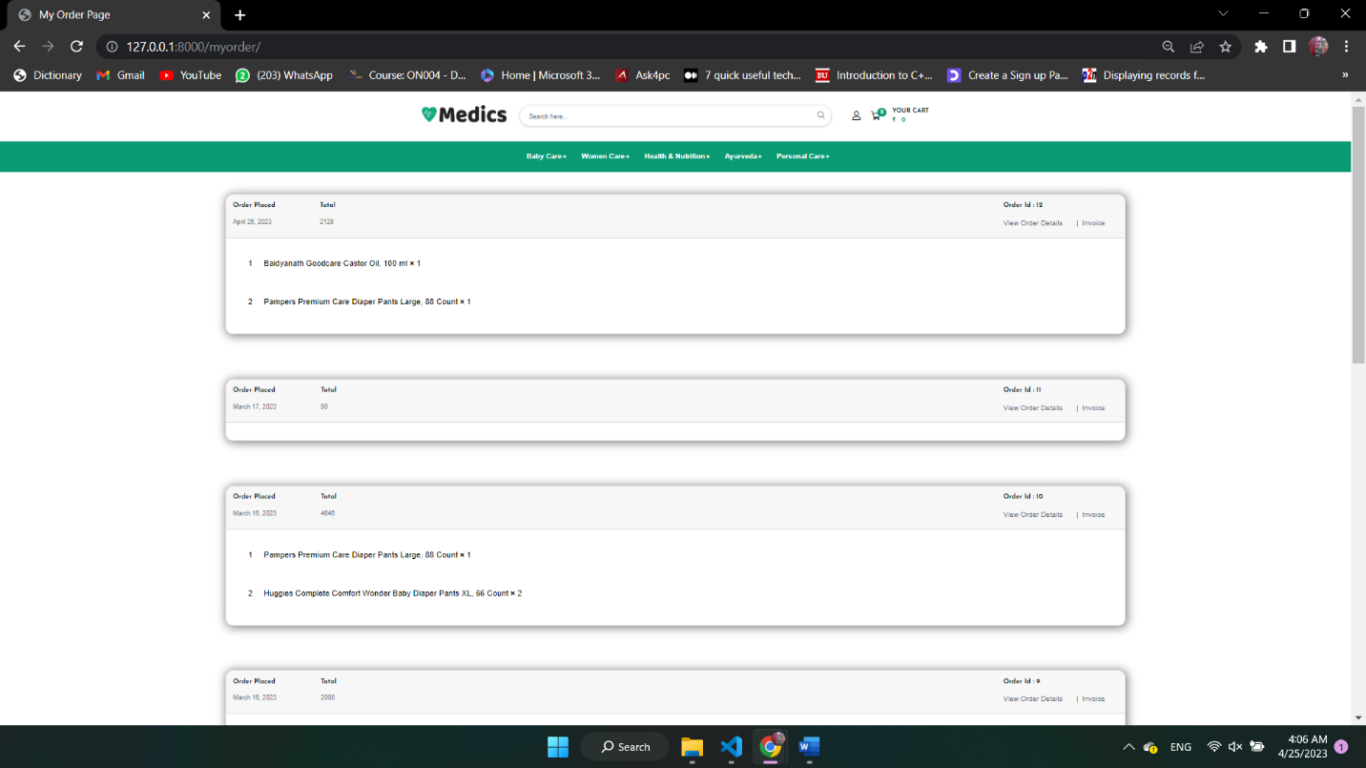**All Orders By User**

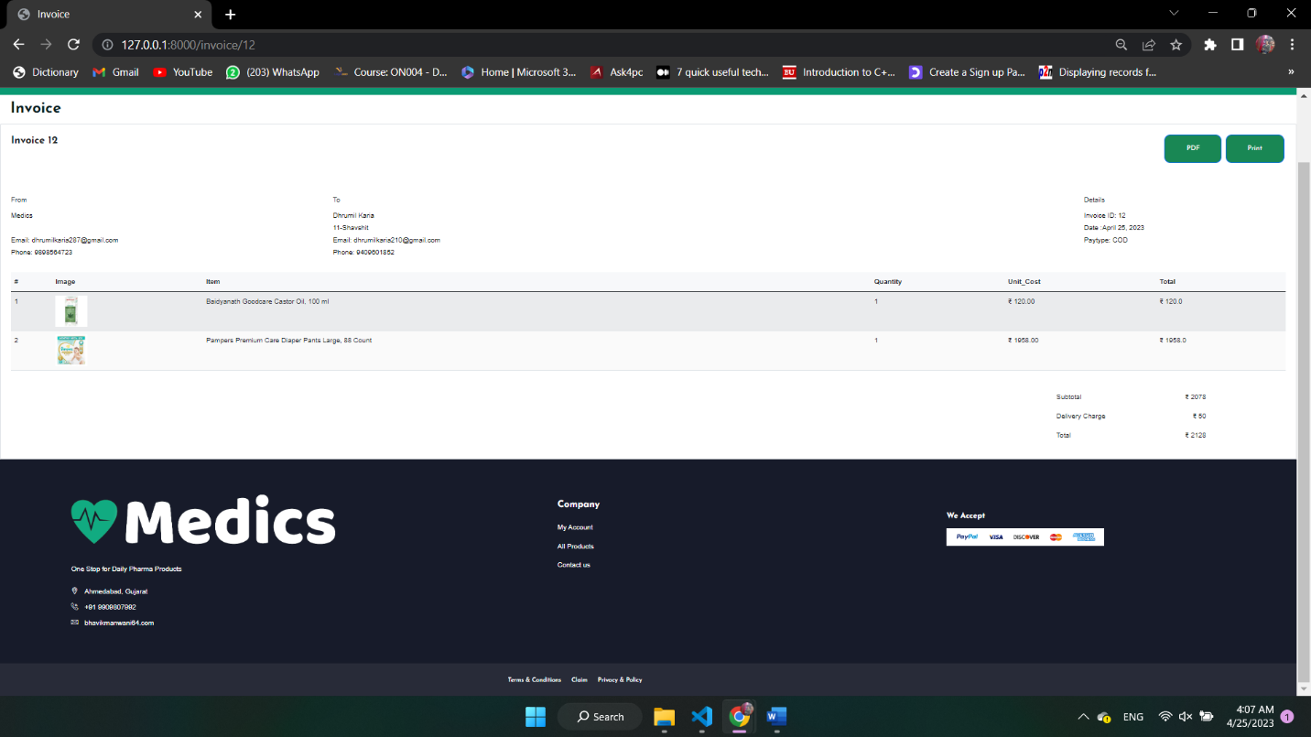**Invoice**

**Future Enhancement:**

* Order tracking
* Find the nearest store
* Prescription Upload
* Coupon code
* Cash on Delivery
* Delivery Boy

**Bibliography:**

Reference By:- Apollo Pharmacy, Pharm Easy and 1mg